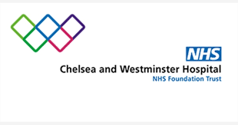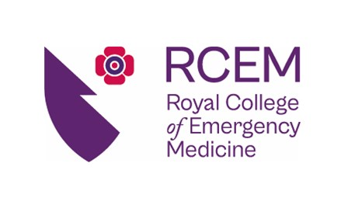

**North West London HST Regional Training Day**

23 February 2022

ED Seminar Room, Chelsea and Westminster Hospital

Internal Consultant: Dr Meehar Shah

External Consultant: Dr Radhwan Dheya-Aldin

|  |  |  |  |
| --- | --- | --- | --- |
| Time | Session | Presenter | Curriculum |
| 0845 – 0900 | Welcome and Housekeeping | Kerry Lim |  |
| 0900 – 1000 | Burns Unit and Treating Burns (Part 1) | Nicole Lee  Matron Burns Unit  C+W Hospital | SLO4 |
| 1000 – 1100 | Minor Injuries | Mark Zubiri  Lead Emergency Care Practioner  C+W Hospital | SLO4 |
| 1100-1115 | Break |  |  |
| 1115 – 1215 | The NHS Pension | Peter Reading  Legal and Medical |  |
| 1215 – 1230 | Break |  |  |
| 1230 – 1330 | Treating Burns (Part 2) | Mr Andy Williams  Consultant Plastic Surgeon  C+W Hospital | SLO4 |
| 1330 – 1430 | Lunch |  |  |
| 1430 – 1600 | Challenging Consultations  Complaints Management | Zaina Reinink  MDU | SLO7, SLO11 |
| 1600 – 1630 | Trainee Meeting  End |  |  |