**Candidate Pack**

**For**

**Fellow in advanced laparoscopic surgery / Endometriosis**

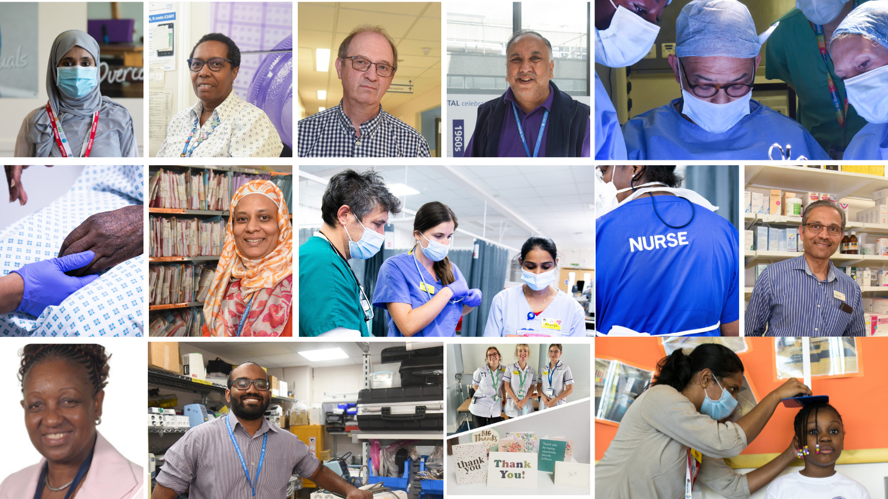

** Follow us on social media**



# The North Middlesex University Hospital NHS Trust is a medium-sized acute and community trust with over 525 beds and over 600 community staff, serving more than 600,000 people living across Enfield and Haringey and the surrounding areas, including Barnet and Waltham Forest.

# The hospital has been on its present site for over 100 years and was established as an NHS trust by statute in December 1990. The Trust’s services are provided on the North Middlesex University Hospital site as well as a range of community sites across the London Borough of Enfield, including at partner hospitals. They provide services in collaboration with a range of partners, including local GPs, acute, mental health and other community health service providers across North Central London.

# In the year ending 31 March 2022, the Trust reported a turnover of £419.7m and employed almost 4,000 staff. Following the transfer of Enfield Community Services on 1st April 2023, this has increased as we have welcomed over 600 new staff including District Nurses, Community Matrons, Community Physiotherapists, Psychologists and many more across a wide range of adult and children’s community services in Enfield. It is an exciting time to join North Mid as we continue our journey to become an integrated care organisation to deliver high quality, seamless care in our local communities, with a focus on tackling health inequalities.

# North Mid is part of North Central London integrated care system – consisting of the NHS and Local authority organisations in Camden, Islington, Barnet, Enfield and Haringey. As with other ICS’s, we are working increasingly closely with partners and indeed many of our financial and performance objectives are measured at this system level. Whilst all organisations remain as standalone, statutory bodies we have an ICS infrastructure for making shared decisions and agreeing shared approaches.

# We are proud of our staff and want to ensure their training allows them to provide excellent clinical care. We are also a training unit for medical students from UCL and St George’s University Grenada, and for nursing and midwifery students from Middlesex and City Universities.

**Our Vision**

At North Mid, we’ve set out sights on Trust North: a set of give clear ambitions which describe our vision for our Trust.

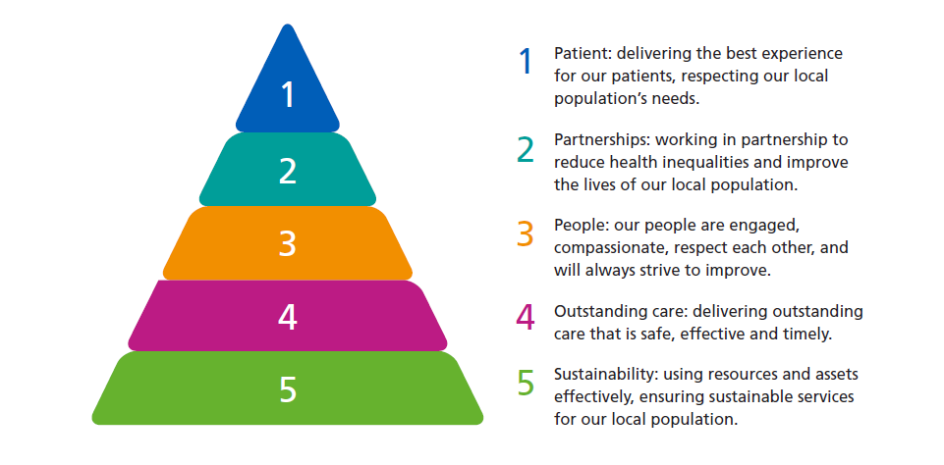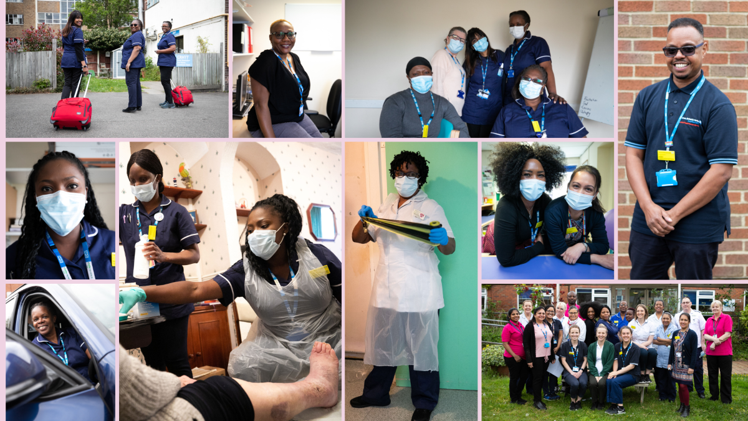

# Additional Information

**Location**

Situated in North London with a multi-cultural community, the area provides a wide range of facilities and is close to the heart of London. Central London is easily accessible, with Liverpool Street and Kings Cross approximately 30 minutes away by public transport.

**Benefits**

We want to attract the best and brightest people to work at NMUH and that means looking after you from the moment you apply for a role at the Trust and throughout your career with us. Our staff are our most valuable asset and we believe that investing in colleagues is crucial if we want to enable everyone to reach their full potential.

**Learning and Development**

As a University Trust, we recognise the importance of investing in our workforce to continue to deliver the right care in the most effective way, based on a sound evidence base and continuing professional development. We offer:

* A structured leadership and management development programme
* Core skills statutory and mandatory training programmes
* A ‘one-stop’ induction programme for all new staff – introducing you to the Trust,
* our values and our services
* A structured programme of learning for trainee doctors, student nurses and students across allied health professions
* A coaching network where trained coaches throughout the Trust are matched with staff of all disciplines to provide a powerful development opportunity
* A wide range of Continued Professional Develop (CPD) opportunities, working with
* partners – such as Middlesex University and University of Hertfordshire, to deliver training and development programmes and support

**Health and Wellbeing**

**We offer a Health Hub which helps improve staff health and wellbeing across the Trust – encouraging staff to step away from their work and think about their own health. This includes:**

* **Workshops, challenges and social events throughout the year**
* **Confidential and safe forums where staff can talk about the emotional impact of their work**
* **An equality and diversity staff network providing support to all staff**
* **Mindfulness bite size taster sessions**
* **Mini health checks**
* **Free, confidential counselling services 24/7**
* **Reduced gym rates at a number of local health clubs/gyms**

**Pay and Annual Leave**

* **Generous annual leave: starting at 27 days and increasing after five and 10 years**
* **Maternity/paternity and shared parental leave schemes**
* **Sick pay for all substantive and permanent staff**
* **Range of flexible working options across the Trust including compressed hours, term time contracts, part-time working etc.**
* **One of the best pension schemes in the UK**

**Road Access and Public Transport**

North Middlesex University Hospital NHS Trust is situated on the North Circular Road, the hospital is within very easy reach of the M25, M1, A1, A10 and A12. The hospital is situated close to the residential districts of North London including Enfield and Winchmore Hill, which all have an excellent environment and schools. Silver Street main line railway station is a 5-minute walk away, with services direct to Liverpool Street Station and Seven Sisters underground Station.

Our community services are based in a various locations around Enfield including:

St Michael’s Primary Care Centre, Gater Drive, Enfield, EN2 0JB

Lucas House, 305-309 Fore Street, Edmonton, N9 0PD

Forest Primary Care Centre, 308A Hertford Road, Edmonton, N9 7HD

Chase Farm Hospital and the Skye Unit, The Ridgeway, Enfield, EN2 8JL

Eagle House Surgery, 291 High Street, Enfield, EN3 4DN

Highlands Health Centre, 3 Florey Square, Winchmore Hill, N21 1UJ

Bowes Road Clinic, 269 Bowes road, Enfield, N11 1BD

George Marsha Centre, St Ann’s Hospital Site

Bay Tree House, Enfield

For more information about the services available at these locations click [here](https://www.northmid.nhs.uk/community-services)

**Our Values and Expected Behaviours**

You are part of Team North Mid, a workforce over 4,000 strong. A big part of working here is having a culture and values that help us to achieve our vision of delivering outstanding care to local people.

**We are caring:**

|  |  |
| --- | --- |
| What it means | Our behaviours |
| * We are compassionate and take time out to check on colleagues and patients * We are understanding and recognise each other as individuals * We are committed to improving our community for colleagues, patients and carers | * Showing empathy * Being curious * Showing humility * Listening to others |

**We are fair:**

|  |  |
| --- | --- |
| What it means | Our behaviours |
| * We respect and understand each other’s differences and backgrounds * We are consistent with providing realistic, clear expectations and constructive feedback * We are always looking for opportunities to develop all our staff and our services | * Being consistent * Listening to others * Supporting each other |

**We are open:**

|  |  |
| --- | --- |
| What it means | Our behaviours |
| * We embrace change and continuously challenge ourselves and colleagues to create meaningful improvement * We ask for help when we need it; we offer help when we see a colleague struggling and we are always open to challenge * We actively look for new ways of working and explore new partnerships across teams, divisions and organisations | * Speaking up * Being curious * Learning from mistakes |

These values are extremely important to us and we expect everyone who works at the Trust in any capacity to share and uphold these values. Further information on the Trust’s values is available on our website.



# Care and Compassion

Ensure that any escalation of care concerns or safeguarding escalations are made robustly through the appropriate channel. Undertake audits and where appropriate cooperate with the corporate nursing team to maintain Trust standards of care.

# Job Description

Position Fellow in Advanced Laparoscopic Surgery / Endometriosis

Salary NHS pay scale

Location North Middlesex University Hospital

Hours 40 per week

Responsible to Clinical Director, Mr Wasim Lodhi.

Accountable to Medical Director

# Key Working Relationships

# Obstetric staff, Midwifery and nursing staff, anaesthetic staff, neonatal staff, administrative staff

# Job Summary

|  |
| --- |
| SENIOR CLINICAL FELLOW IN OBSTETRICS & GYNAECOLOGY – SPECIAL INTEREST IN ADVANCED MINIMAL ACCESS SURGERY / ENDOMETRIOSIS We are looking for a Senior clinical fellow with competencies equivalent to ST5+ level in Obstetrics and Gynaecology, to join our dynamic team of Specialty Trainees as a Fellow in Advanced Minimal Access Surgery.  North Middlesex University Hospital is a BSGE accredited Endometriosis center, and we perform the full gamut of advanced laparoscopic surgeries.  The post holder will be one of the senior clinical fellows in the department and work on the Registrar rota with daytime and resident on-call commitments (1:9 Two tier registrar nights).  The fellowship is for 12 months and upon agreement with the trainee, it can be extended to 2 years enabling the trainee to obtain advanced laparoscopy ATSM certification from RCOG. Advanced laparoscopic surgery for the excision of benign disease (ATSM) Training in NMEC (North Mid Endometriosis centre) will be in accordance with the RCOG advanced laparoscopy curriculum. Non-London trainees will have the option to obtain advanced laparoscopy ATSM certification from RCOG upon approval from base deanery. |

# Main duties of the job

|  |
| --- |
| The post will ideally suit a candidate who wishes to develop specialist knowledge and skills in managing women with severe endometriosis and other common and complex benign gynaecological conditions. The 2nd aim of this fellowship programme is integrating the successful fellow into our research and training projects.  The successful fellow should expect to become surgically proficient in excising mild and moderate endometriosis and become experienced in other minimally invasive surgical techniques for hysterectomy, fibroids, and complex adnexal problems. The final training targets could be adjusted according to the successful candidate’s needs and previous experience. Travelling Fellowship Successful candidate will potentially be sent to other larger endometriosis centres in the UK for 2 weeks to obtain a more wholesome experience. This will be fully funded. There is ample opportunity to attend fully funded advanced laparoscopic courses as well. |

# Working for our organisation

|  |
| --- |
| The new fellow will work with their mentor (Mr Parveen Verasingam) to augment the current Endometriosis service.  The job will involve weekly specialist gynaecology endometriosis clinic, a bi-monthly minimal access theatre list and an alternate week session for research.   The successful candidate will be expected to be part of the on-call and elective rota to cover both gynaecology and maternity. This includes additional benign gynaecology clinics and theatres and occasional antenatal clinics. Training will be protected as much as possible.  Successful candidate is also expected to join regular colorectal and urology laparoscopic sessions. |

# Detailed job description and main responsibilities

|  |
| --- |
| The post holder will participate in departmental teaching, audits, and governance meetings. There will also be the opportunity to take part in research.  We are a district general hospital Obstetrics and Gynaecology department with over 4000 deliveries per year, a busy acute gynae service and elective gynaecology. We aim to provide a high-quality service for our patients in line with the Trust philosophy. |

Person specification

**Qualifications**

Essential criteria

* MBBS
* Full GMC Registration (or eligibility to obtain).
* MRCOG

Desirable criteria

* MD, PHD

**Clinical Experience**

Essential criteria

* Four years of experience in Obstetrics and Gynaecology in the UK or equivalent

Desirable criteria

* Experience as ST5 and above
* Post-CCT

**Specific Additional Skills**

Essential criteria

* Basic Surgical skills

Desirable criteria

* ALSO, MOET or equivalent course within last 4 years
* Specialist skills relevant to the special interest

**Management Skills**

Essential criteria

* Computer literacy- word excel and able to use Electronic patient records

**Experience in Training, Audit and Research**

Essential criteria

* Evidence of participation in Clinical audit projects

Desirable criteria

* Relevant research articles in peer-reviewed journals
* Evidence of experience in Minimal access gynaecology.

**Personal Qualities**

Essential criteria

* Demonstrate ability to work with colleagues as part of a multidisciplinary team
* Effective written and verbal communication skills
* Commitment to personal development and clinical governance
* Adaptive skills to changing working procedures
* Enthusiastic
* Potential to cope with stressful situations and undertake responsibility

# Interview process

Interview will be held in North Middlesex University Hospital, tentatively scheduled on the 21st of march 2024.

The interview process consist of stations which include CV station and 2 other stations which may include a laparoscopic simulation station. The entire process is expected to last 60 mins. Results will be given on the same day.

# Introduction to the Department

The North Middlesex Hospital is in a state of rapid change with a brand new “purpose-built” Accident and Emergency Department which houses a Gynaecology Emergency Room. We have an active Early Pregnancy Assessment Unit/ Emergency Gynaecology Unit, with two trained nurse ultra sonographers plus 5 Consultant sessions, two ultrasound machines with pulsed colour Doppler facilities, and daily beta-hCG assays. There is a dedicated endometriosis service and NMUH is a designated Endometriosis Treatment centre.

The hospital has been designated as a Cancer Unit within the “North Central” London Oncology network.

There are modern, up-to-date facilities for minimal access gynaecological surgery including video cameras, laparoscopes, hystero-resectoscopes, and Novasure endometrial ablation. The success of the service has led to increased demand for minimal access surgery from GPs and patients. There are weekly out-patient hysteroscopy clinics and colposcopy clinics.

There is at present one weekly gynaecological urodynamic session. Enfield and Haringey Health Authority employ a senior nurse incontinence advisor and there is an active incontinence support group with a senior physiotherapist.

Currently the department caters for around 4200 deliveries per year. Large proportion of our women are from ethnic minorities with associated problems such as pre-eclampsia, sickle cell disease, thalassemia, HIV and substance abuse, although the perinatal mortality rate is currently around 6 per 1000. The new unit has opened in November 2013 and has a Midwifery-led unit and a Labour ward with 18 delivery suites, 3 high dependency rooms and 2 theatres.

***Current Medical Staffing***

**Consultants:**

|  |  |
| --- | --- |
| Mr Adewale Adeyemo MRCOG | Lead for Maternal medicine |
| Miss Ansam Al-Habib FRCOG | Lead for Infertility |
| Mr Abiodun Fakokunde FRCOG | Complex Gynaecology |
| Miss Abha Govind DGO FRCOG | High risk Obstetrics/ Fetal Medicine |
| Miss Deepa Janga FRCOG | Fetal medicine Unit lead/Minimal Access Surgery |
| Miss Akila Karthikeyan MRCOG | Gynaecology Cancer lead/ RCOG College Tutor |
| Miss Ashwini Kulkarni MRCOG, MD | Maternal Medicine/Prenatal Diagnosis |
| Mr Joe Llahi MRCOG | Deputy Divisional Clinical Director  Lead Colposcopist |
| Mr Wasim Lodhi FRCOG | Clinical Director  Outpatient hysteroscopy Lead |
| Mr Elexie Opara MRCOG | Risk/Governance Lead |
| Miss Henna Rather MRCOG | Maternal Medicine/Labour ward Lead/  Deputy College Tutor |
| Ms Schaharazed Rouabhi MRCOG | Emergency Gynaecology/EPAU lead  Deputy Clinical Director |
| Ms Viswa Sivashanmugarajan MRCOG | Early pregnancy Assessment Unit |
| Miss Beena Subba FRCOG | Early pregnancy Assessment Unit |
| Mr Parveen Verasingam MRCOG | Endometriosis lead |
| Mr Wai Yoong FRCOG | Urogynaecology lead |
| Ms Victoria Sampson | Vulval Disorders Lead |

**Junior Doctors**

* ST3 and above/Equivalent Regstrars 20
* ST1-2/Sho Equivalent 14
* FY2 2

# ****TRUST POLICIES****

# ****Probation****

# Employment by the Trust is subject to a six (6) month probationary period, during which time you will be required to demonstrate to the Trust's satisfaction your suitability for the position in which you are employed. During your probationary period, your employment may be terminated by you or the Trust by providing one (1) week notice in writing.

# ****Equality, Diversity and Inclusion****

The Trust is committed to fair and transparent recruitment and selection procedures and to providing a workplace where all staff are treated with respect and feel included. It is the aim of the Trust to ensure that no job applicant or employee receives less favourable treatment because of age, disability, gender reassignment, marriage and civil partnership, pregnancy and maternity, race, religion or belief, sex, or sexual orientation.

**Health & Safety**

Employees must be aware of the responsibilities placed on them under the Health & Safety at Work Act 1974 to maintain a safe environment for both staff, patients and visitors, to observe obligations under organisational and departmental Health & Safety policies, maintaining awareness of safe practices and assessment of risk.

**Data Protection and Caldicott**

To obtain, process and use information (held on computer and/or manual filing systems) in a fair and lawful way. To hold person identifiable information for specific registered purposes and not to use, disclose or transfer person identifiable information in any way that is incompatible with the Data Protection Act 2018, other legislation and Caldicott requirements. To disclose person identifiable information only to authorised persons or organisations as instructed. When using email to transmit person identifiable information within or outside the Trust, the Trust Email Policy must be strictly followed.

**Customer Care**

The aim of the hospital is to provide patients and clients with the best possible care and services. In order to meet this aim, all our staff are required at all times to put the patient and client first and do their utmost to meet their requests and needs courteously and efficiently. In order that staff understand the principles of customer care and the effects on their particular post and service, full training will be given.

**Infection Control**

All healthcare workers have an overriding duty of care to patients and are expected to comply fully with best practice standards. You have a responsibility to comply with Trust policies for personal and patient safety and for prevention of healthcare associated infection (HCAI); this includes a requirement for rigorous and consistent compliance with Trust policies for hand hygiene, use of personal protective equipment and safe disposal of sharps. Knowledge, skills and behaviour in the workplace should reflect this; at annual appraisal you will be asked about application of practice measures known to be effective in reducing HCAI.

**Smoking Policy**

The Trust provides a smoke free work environment.

**Confidentiality**

Under no circumstances, either during or after the end of your employment (however it is terminated), may you divulge any unauthorised person confidential information relating to the Trust. This includes but is not limited to, information covering patients, individual staff records, industrial relations, financial affairs, contract terms and prices or business forecasts.

**Clinical Governance**

Staff are expected to provide patients with timely and effective care. Treatment and direct / indirect support must be based on best practice. Everyone is responsible for this and his/her job in the Trust is important in achieving this.

**Rehabilitation of Offenders Act**

This post is exempt from the Rehabilitation of Offenders Act 1974. Should you be offered the post it will be subject to a criminal check from the Criminal Records Bureau before the appointment is confirmed. This will include details of cautions, reprimands, final warnings, as well as convictions.

**Safeguarding Vulnerable People**

It is a basic human right of every child and adult to be protected from harm and NHS Trusts have a fundamental part to play in this. We expect all our staff to recognise signs of vulnerability and to report and act on any concerns in line with policy and guidance contained in 'Working Together - Every Child Matters' and 'No Secrets - guidance on developing multi-agency policies and procedures to protect vulnerable adults from abuse' on which our Trust Polices are based.

**Organisational Change**

As services develop and change, the post-holder may be required to undertake other responsibilities within the Trust.

**Review**

This job description is an outline, which reflects the present requirements of the post and is not intended to be an inflexible or finite list of duties and responsibilities. As these duties and responsibilities change and develop the job description will be amended from time to time in consultation with the post-holder