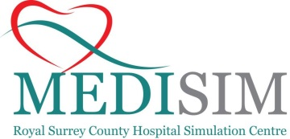



**Reg Ready**

**Registrar Ready Course 13th June 2022**

**Royal Surrey County Hospital Medical Education Centre**

**Morning Session: Room A4**

08:45 – 09:00 Registration + Tea

09:00 – 09:45 Introduction – The Role of the Medical Registrar

Dr Ibrahim Bhatti & Dr Jac Jones

09:45 – 10:00 Meet the Mannequin and House Rules

Dr Jac Jones

10:00 – 10:45 Scenario 1 + Feedback

**Tea break**

11:00 – 11:45 Scenario 2 + Feedback

11:45 – 12:30 Scenario 3 + Feedback

**12:30-13:15 Lunch Room A4**

**Afternoon Session: Room A4**

13:15 – 14:00 Scenario 4 + Feedback

14:00 – 14:45 Scenario 5 + Feedback

**Tea break**

15:00 – 15:45 Scenario 6 + Feedback

15:45 – 16:15 Group Discussion, Questions and Course Evaluation