Completion of Patient Satisfaction Questionnaires (PSQ) on paper
& Procedure for uploading onto Axia

Attached is a paper copy of the Patient Satisfaction Questionnaire.
This can be printed out on paper and given to patients to complete.

The minimum number of questionnaires required in the portfolio is 20 by your July FRCP.
10 of which should be present for your IRCP in February.

The paper questionnaires collated can be transferred to the DCT Axia portfolio subsequently.

Process to transfer to the Axia portfolio:

This can be done by the DCT, Educational Supervisor or any other colleague of choosing.

- To be able to complete the PSQs it is essential to “register a team member account”.

It is important to note that this account must have a different email address to any existing Axia accounts.
A GDC/ GMC number is not required for this account.

The account can be registered by: -
- the DCT themselves
- Educational Supervisor
- Any other member of the team
There can be more than one registered for uploading PSQs if required.
- Next, the DCT needs to Link this Team Members account.

The trainee starts by using the ‘Commence Patient Satisfaction Questionnaire’ button in the ePortfolio.

- The DCT links the team member(s) account to the ePortfolio by entering their email address (as per email address used to set up the team member account) and then searching for their account on the system.

Press the blue “Add” button. The link is complete

- Once the team member is linked, they can log into Axia and select the relevant DCT trainee (in case more than 1 is linked).

The team member will have a button to ‘Start Patient Satisfaction Questionnaire’.
Dental Core Trainee

- This will open a new questionnaire for completion.

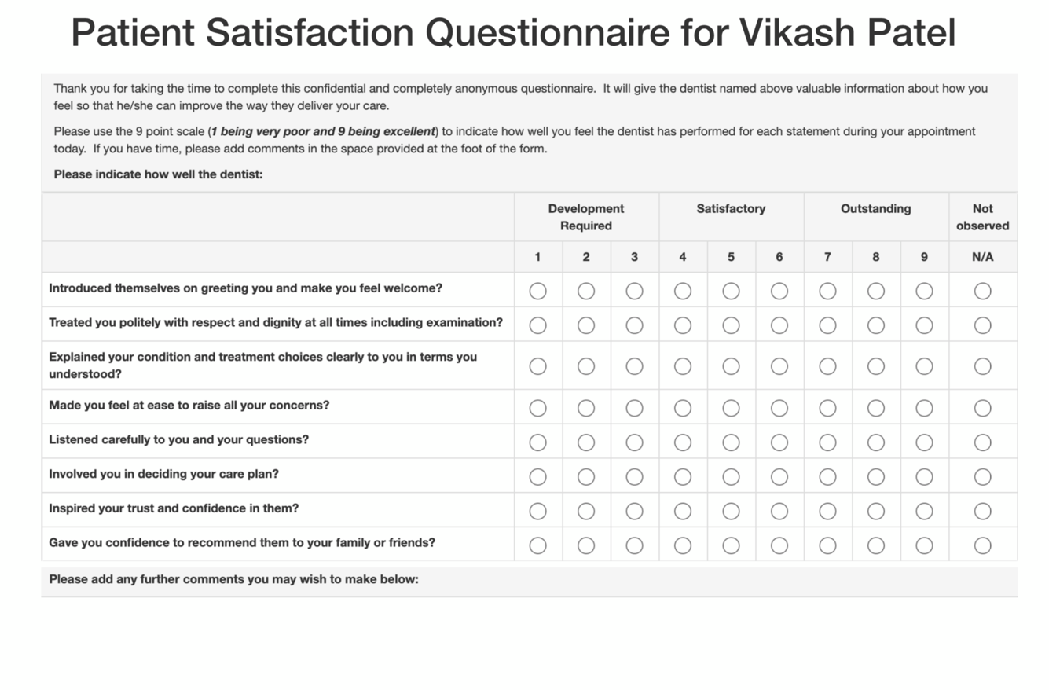
The details from the paper form can be copied into this & completed.

