Global Health Fellowship/Time Out of Programme.
Trainee Experiences.

Dylan Goh
Dylan.goh3@nhs.net
Gurkha Welfare Trust, Nepal
https://www.gwt.org.uk/
Aug 24-Apr 25
Primary care team/Medical Cell
Nepal is a country that conjures images of tall mountains and ancient traditions. My time in Nepal as a global health fellow taught me about the culture of an ancient country and shed light into the challenges and successes of providing healthcare in some of the hardest to reach places in the world. Nepal's cities are divided mainly by altitude, ranging from the plains to the Himalayan mountains and therefore Nepal's weather can differ quite greatly based on its geography. Monsoon often brings heavy rains and dangerous floods, but often relief from the dust that lingers in the air in Kathmandu valley.
Culturally, the Nepalese people follow Hinduism and Tibetan Buddhism. The older generations are more religious and superstitious compared to the younger generation, but religion remains a strong pillar in society.
My time in Nepal was spent on a quality improvement project for the Gurkha Welfare Trust (GWT). Much of this involved observing healthcare workers (mobile health practitioners, nurses, doctors, physiotherapists) work together with welfare officers to provide comprehensive care for the Gurkha veterans and their families. My final project was the development of a guidebook developed for the mobile health practitioners. These were trained healthcare assistants who would travel long distances to remote and rural areas to assess and provide care for those who lived there. Integrating with the team was an easy process for me, with a welcoming team of supervisors and friendly colleagues. There was always communal lunches and morning and evening tea breaks where we could interact and talk about our upcoming plans. I also had the opportunity to celebrate many festivals with the team in Kathmandu, learning about some of the traditional festivals and celebrations. The GWT is spread across the whole of Nepal and I had the opportunity to see a few parts of Nepal and travel to some of the more remote villages. There were many informal teaching sessions that I hosted with the medical team I was with, and similarly, the medical team had quite a few teaching sessions by the doctors there.
I was provided accommodation by my supervisor which was a room in a shared homestay. Living with locals gave me a better understanding of Nepalese culture and what the city has to offer and where the local haunts were. I was introduced to other locals and spent many weekends exploring the city with them. There is good signal throughout the cities, and there is strong mobile network coverage and wifi. Most locals are friendly and will try their best to help. Nepal felt like a safe place to me throughout my travels and I often bumped into other travellers passing through. Navigating around Nepal can be challenging due to the language barrier, but most people take coaches for intercity travel and taxis or motorcycles and scooters for travel within the city. Cash is still more widely accepted than card, although most tourist areas allow card transactions. I managed to organize a trek to Everest Base Camp whilst in Nepal, and it was an amazing experience to see what people typically think of when they think of Nepal.
The whole experience really taught me many lessons on the provision of healthcare in countries with limited resources and difficult to reach places. It also reveals the strength of a system that combines social and health care. Despite challenges in healthcare and healthcare access, GWT has been an inspiration to me in understanding a healthcare system. My highlight of the trip was celebrating the many festivals with my warm colleagues throughout GWT, I never felt like a stranger whilst in their company. The trip brought challenges such as visa issues and applying for a stipend, but these challenges were eventually overcome.
The Global Health Fellowship provides an unforgettable experience all thanks to the strong links between the global health fellowship programme and grassroots organisations. I believe this experience has introduced me to a unique organisation working outside of the public and private sector that is providing high quality primary care to a specific population despite challenges in geography and access to services.

June 2025

Dr. Joanna Hixson.
Diploma in Tropical Medicine and Hygiene Liverpool School of Tropical Medicine
Tshemba Foundation in Limpopo/ Mpumalanga, South Africa.
My OOP year between August 2022 and July 2023 consisted of 2 main parts; firstly, completing the diploma in tropical medicine and hygiene with the Liverpool School of Tropical Medicine and secondly, volunteering in a rural hospital in South Africa. I made use of the time in between the diploma and the volunteering post by locuming as a medical SHO in Croydon University Hospital.
I enjoyed studying for the diploma and every aspect of my time in Liverpool. The course provided me with a good foundation of knowledge of infectious diseases such as; HIV, malaria and TB. I also learned about the clinical presentation and management of other diseases such as; amebiasis, parasitic infections, fungal infections and malnutrition. The course also provided insight into the double burden of disease that challenge low to middle income countries.
After the diploma I had a 2 month window before I was due to go to South Africa. I spent this time locuming as a medical SHO in Croydon. The work was busy but rewarding and it was good to keep up with clinical work.
I spent the second half of my OOPE year volunteering with the Tshemba Foundation in Limpopo/ Mpumalanga, South Africa. This post consisted of clinical work in Tintswalo Hospital and the surrounding outreach clinics plus helping out with the clincial teaching and some quality improvement projects.
I found the clinical work to be a steep learning curve and I encountered many cases that I had not had much experience working with in the UK. I spent my time split between the paediatric ward, the adult and paediatric out patient departments and working as a sessional doctor in 2 of the primary healthcare clinics.
Working on the paediatric ward and built my understanding and confidence in the assessment and management of children presenting with acute malnutrition, TB, respiratory illness, gastroenteritis and more than once, sadly, advanced undiagnosed HIV.
I spent my afternoons working in the paediatric out patient department. This consisted of follow up reviews for patients who had recently been discharged, TB workup, fungal skin infections, bronchiolitis and reviews for the management of chronic diseases such as epilepsy.
I also worked the occasional shift in the adults out patient department which consisted of acute and chronic reviews of patients with renal disease, MSK issues, chronic pain, respiratory disease, hypertension.
As Tintswalo was a rural district hospital senior support was often sparce. Advice was often given over the phone from the nearby referral hospitals and it was endeavoured to transfer patients, both successfully and unsuccessfully, if they needed higher level care.
I enjoyed working in the outreach clinics as a sessional doctor. Patients were either presenting acutely after being triaged by the nurses or as follow up patients. It was helpful to have a regular weekly routine so we could see our own follow up patients.
I also presented weekly teaching to ward nurses as part of a ‘back to basics’ teaching programme. The aim was to start from the clinical basics and refresh their knowledge in normal and abnormal vital signs and why we monitor them, CPR, SPAR handovers and pain management. I enjoyed building rapport with the nurses and it was satisfying to see an increase in some of their clinical confidence.
Ialso helped out with some quality improvement projects with the paediatric ward. Including creating bed numbers and file numbers and encouraging the nurses and wider MDT to make use of them. I also put up a board to encourage communication between the nurses and the doctors by way of a daily boardround.
I helped out with a few smaller projects such creating a table of normal and abnormal vital signs for display in the adult medical and surgical wards to assist the nurses when wishing to escalate a patient for a senior nurse or doctor review.
As volunteers, we were treated to accommodation in a game reserve in Limpopo. We shared accommodation with other medical volunteers from a wide variety of places including South Africa, Canada, the Netherlands, Germany and the UK. It was great to have a support base within the lodge from other doctors of varied training and career pathways. Many of whom offered continual advice over WhatsApp after leaving the foundation.

I found the work to have many challenges such as; medical complexity, language barriers, cultural traditions (usually through use of herbal medicine), unclear referral pathways, limited medical supplies and loadshedding (nationwide scheduled powercuts).
However, I also found the work incredibly rewarding and I was happy to have a long volunteering stint compared to some other volunteers. This allowed me time to build rapport with the local staff, adjust to the language, culture, and build on my confidence with clinical work.
Overall, I would highly recommend to any GP trainee to work with the Tshemba Foundation and I would gladly come back at a future date to volunteer if I am able.

August 2023

Dr. Juliet Evans GP Global Health Fellowship Calcutta Rescue, Kolkata, India
I undertook the Global Health Fellowship in Kolkata, India between August 2022 and July 2023. The role is as a Medical Officer with the charity Calcutta Rescue (CR).
The charity was started by a British doctor in the 1970s to provide basic medical care for the people living on the streets of Calcutta. It remains dedicated to helping the slum dwellers of the city, of which there are 7000 slums, some registered and some not recognised by the government. CR started as a street medicine clinic providing immediate care to patients under a tarpaulin on the pavement. It has grown to now have four primary care medical clinics, two street medicine buses, two schools, a living standards department and a handicrafts centre dotted about the city. It has become self-sufficient so that the need for international volunteers has reduced as the charity now employs local skilled workers.
My role was not to provide clinical input, but to be a ‘fresh pair of eyes’, using my experience of clinical audits and management to help progress the workings of the clinics. I wanted to do this fellowship in order to broaden my horizons, challenge myself, and see medicine being practiced in a completely different setting. My husband who is an accountant accompanied me and helped the business side of the charity in the main office.
Before I arrived, I was given a list of projects to do throughout the year; these included creating an SOP for the HIV clinic, Teaching CPR, creating a community health needs survey, and enhancing the gender based violence support system in the medical clinics.
When I arrived in Kolkata I was introduced to everyone and given a two-week induction tour around the various different sites. It took several months to adjust and get used to the culture of living in Kolkata, but thankfully the team were very understanding. One positive of being there was that my work was very autonomous and I was left to structure and organise my work as I chose. My day to day timetable was flexible. I went into the clinics twice a week and the remaining days I worked from home or in the main office. A large part of my work was around people skills and communication; I led meetings, created concept documents, forged connections with other NGOs and visited government hospitals for research. A huge learning point was that big culture differences exist in every aspect of life, and I had to focus hard on communication skills to ensure clear understanding on both sides.
My first project was to re-organise the HIV clinic, this was run twice a week in the Tala Park Clinic in North Kolkata. I spent two days a week sitting with the doctors and observed them seeing patients. I made a detailed observation of how the clinic ran from when the patient arrives, to when they left. I visited the government HIV centre in the centre of Kolkata and had meetings with the professor there. I conducted a patient questionnaire translated in Bengali, to learn more about how our patients felt about their diagnosis and our services, and if they felt they could be improved. I learnt that a lot had changed in the health landscape of the city since the clinic was started many years ago, and I made a new SOP to reflect this and held meetings with the doctors and clinic managers to implement positive changes. One cultural difference that immediately struck me was the natures of the consultations and doctor-patient relationship. Not only is there no confidentiality, as all consultations are conducted in plain view of everyone in the clinic, but the tone of voice and language used by the doctors often comes across as quite abrupt and insensitive.
Having spent many weeks in the clinics and time in the government hospitals, I came to understand that the mannerisms expressed by the doctors appeared to be the norm here; the doctors are seen as ‘gods’ and the patients rarely question or speak back to them. The amount of time the doctors spend listening to the patient is minimal, and patients do not seem to expect a ‘touchy-feely’ interaction. It made me question the quality of the doctor-patient relationship, and how much empathetic support is shared with patients compared to what I am used to in the UK.
A significant learning point for me has been that it is very difficult to instigate changes in a healthcare system. I have gathered my evidence and suggestions for developing new structures to clinics so that they run more efficiently and patients get better care, however when it comes to implementing the new structures it has been challenging on many levels. I have learnt not to expect rapid change and that to implement anything meaningful it has to be championed by the people running the clinic, and not just by me as an ‘outsider’. To this end I have been developing my ability to explain, communicate and listen, all of which is layered with even more complexity by language and cultural barriers.
A significant part of my role was running teaching sessions. I taught everyone in the organisation (about 200 people) Basic Life Support. Because of the language barrier, most people speak Bengali, I had to think of creative ways to get across the information. Luckily, I found a good CPR video on YouTube in Bengali. I used a dummy patient to bring the session to life so that everyone could practice the technique. It was a fun experience and everyone enjoyed having their own practice, and we had some laughs along the way. I made laminated CPR posters for every clinic, and ensured the emergency medication boxes were well equipped and up to date.
I also conducted Hand Hygiene sessions and Anaphylaxis training. As part of an Antenatal Clinic project I reviewed the services to see what could be added, such as anti-helminth treatment for anaemic mothers.
All in all, I had a brilliant time working at Calcutta Rescue. No two days are the same, and every day brought a new adventure or experience in this incredible city!
October 2023

Dr Tim Robinson
Global Health Fellowship South Africa.
I worked in Tintswalo Hospital in Mpumalanga, north-east South Africa, between February and July 2022. It was a hugely rewarding experience, both within and outside the hospital environment.
Setting
The placement was organised through Pro Talent and the Tshemba Foundation – a non-profit organisation that arranges medical volunteering opportunities in Mpumalanga.
Tintswalo Hospital is a 350-bed level 1 district hospital with Emergency, Medical, Surgical, Paediatric, Obstetric and Psychiatric wards. There is also a busy outpatient department as well as HIV, TB and eye clinics on site.
Job Responsibilities
I primarily worked on the female medical ward, and also helped out in the emergency and outpatient departments. The hospital was predominantly run by “community service” doctors in their third year post-qualification. I was amazed by the breadth of their knowledge and skills, which included anything from manipulating a fracture under sedation, performing emergency C-sections, leading paediatric resuscitations, and providing anaesthetics cover for theatres. There were plenty of opportunities for me to assist in these situations, and I picked up some really useful procedural skills during my time in the hospital.
The Tshemba Foundation provides support in both primary and secondary care settings, and volunteers are encouraged to assist at local primary health clinics as well as Tintswalo Hospital. I therefore divided my time between these two settings, which allowed me to get a broader understanding of the most common conditions affecting the population.
There was a significant burden of non-communicable disease in primary care, and it was common to see patients with extremely poorly-controlled hypertension and diabetes, as well as new presentations of end-stage renal failure. Working in the hospital alongside the clinics allowed me to see the other side of this coin, with strokes in particular being common and carrying a poor prognosis.

The HIV prevalence in Mpumalanga is approximately 15%, and again I saw both sides of how this is managed in primary and secondary care. I was impressed by how well HIV was managed in the community. The nurses were very knowledgeable and many patients were compliant with ARVs. Sadly, however, a large proportion of inpatients at the hospital had AIDS-defining illnesses.
I became familiar with conditions that I had only come across in textbooks, including TB (pulmonary and extrapulmonary), cryptococcal meningitis, PCP and one case of cerebral toxoplasmosis.
Training and Teachimg
Volunteers with Tshemba are encouraged to engage in teaching sessions and/or lead a quality improvement project. Being based on the medical wards, I noticed that a lot of medications were often not prescribed properly or not signed for. I felt there was scope to improve the prescription chart, so designed an updated version. Although I wasn’t there to see the project completed, I have been informed that the new chart is now in use. Other projects included teaching nurses on BLS, improving the triage system in the emergency department and leading a drive for contraception through the family planning clinic at the hospital.
Challenges
Of course, as expected, there were some challenges associated with working in a rural hospital in sub-Saharan Africa. The nearest referral hospital was a three-hour drive away, and patients were usually either not sick enough or too sick to be transferred – that’s if we were able to get through to the right person! Trying to arrange CT scans was similarly frustrating, and often involved speaking to several hospitals who would give conflicting information. Even if the scans could be arranged, the next hurdle or arranging transport then had to be overcome.
Aside from these logistical challenges though, the hardest thing for me was to adjust to seeing relatively young patients dying, and the way this was the norm for staff in the hospital. Sadly, the prognosis for patients with advanced HIV was so poor that these patients invariably would not be accepted for transfer to referral hospitals, so it was not uncommon to see patients in their 30s and 40s being “not for resuscitation” – something that would be unthinkable in the UK. I also looked after a number of patients who died of other things where I felt more could and should have been done.
There were some success stories, though, such as helping to arrange a helicopter transfer to a referral hospital (and listening to patients cheering when the heli landed in a nearby field), or seeing a child in a primary health clinic with suspected meningitis and personally taking him to hospital (an ambulance would have taken too long) – it turned out he did have meningitis and thankfully he made a good recovery.
Outside Activities
There was plenty to do outside of the hospital too. As volunteers, we had evenings and weekends off, and made the most of our free time. We lived in beautiful accommodation in a “Big Five” game reserve, where it was possible to see giraffes outside your bedroom window or watch impala drinking from the watering hole while we ate breakfast. I will never forget the magical feeling of falling asleep while listening to a lion roar in the distance, or that slightly-too-close encounter with elephants on the way back from work with another volunteer.
Sharing accommodation with fellow volunteers was great, and allowed us to form firm friendships. We had regular braais, and would often cook together or play cards during the frequent periods of load shedding (power cuts). Parkrun, followed by coffee and breakfast, was a regular Saturday morning activity, and I joined a local football team with another volunteer.
Living on a game reserve, we also regularly went on game drives, while Kruger National Park was only 45 minutes away. There were also hiking trails and waterfalls to explore around the stunning Blyde River Canyon. Mpumalanga really was full of beauty and variety. I am so grateful for the opportunity to live and work in South Africa. I became a more confident and resourceful dokotela (doctor), and pushed myself to become more of a leader.
I would recommend the Global Health Fellowship to any trainee with an open mind who is looking for a fresh challenge and the chance to do something a little different with their career.
July 2022

Amy Dehn Lunn
E mail: amydehnlunn@gmail.com
Clinical Fellow in Global Health and Leadership, Calcutta Rescue, Kolkata
August 2016-17
Location: Kolkata, India
Website/ information available: http://www.calcuttarescue.org/
Description of Clinical setting: clinics and outreach in mobile clinic van/ambulance to slum communities.

Clinical resources :
Basic clinical resources: BP cuffs / otoscope / opthalmoscope always, sats probes sometimes available but I think this has improved since my last visit. Bring a good stethoscope. Depending on the clinic, can do blood tests, and charity is looking into innovative new ways to check basic blood tests in mobile clinics. Clinics have basic facilities e.g. desk, chairs, examination couch. Range of medications available, given to patients free of charge.

Main responsibilities of job:
Depends on your personal interests / skills plus the needs of the organisation at the time. Combination of clinical work, quality improvement and service development.

Organisational issues:

Work colleagues: great place to work, keen to embrace improvement, responsive to new ideas. Lots of support from the deputy CEO in charge of the medical projects and from the CEO of the organisation. Largely very dedicated colleagues (doctors and healthcare professionals). Consulting styles can be very different to UK and patients are seen at a table alongside other doctors; difficult to have private consultations.

Salary /annual leave: stipend £300/month. This covers living costs but not holidays etc. Annual leave two weeks every four months.

Mentorship and clinical support: You will be working under the supervision of a local doctor rather than register with the Indian Medical Council. In practice once you get used to working there and build good relationships with your colleagues you will find that this supervision is minimal. In fact, the supervision aspect can be helpful in provoking conversations about different management approaches – I never found that a plan argued for was changed by another doctor; they would always sign it off after I defended it. Dr Ghosh, deputy CEO, will be your clinical supervisor in terms of assessments. She will also support you in improvement projects. Mentorship will be provided by previous fellows via skype/whatsapp.

Accommodation: Various options available. I rented a flat as wanted more independence and this option worked really well for me. Cost is about £200 per month for a 1-2 bed flat. The charity is likely to have other international volunteers; short term volunteers generally stay at the house of Calcutta Rescue’s governing council member Shomir Choudhuri. This would be a good place to settle in and get to know other volunteers. However, it can be harder to make it feel like your home as you may need to move rooms or sometimes even stay in a hotel briefly depending on his family situation. There are also quite a lot of rules! Rent is paid to Shomir in UK money and then donated to Calcutta Rescue. There are other homestays and hotels but these can be expensive.

Communication:
You will need to get a local sim card. I used this as a hot spot for wifi and this was very affordable – you can often buy package deals pay as you go which work well.

Description of local community:

Kolkata is a busy city, and it can take time to settle in and find your way around. Air pollution can be a problem – do be aware of this particularly if you have respiratory problems. The city has a fast, reliable metro line running north to south, which I used for my commute. Depending on where you are based, you can walk to and from the metro or get an auto rickshaw. Ubers are cheap and easy to use, would recommend these at night or when going out of metro zone. The metro shuts at 10pm. Yellow cabs are also available but you may not get a good deal on fares. I felt very safe in Kolkata - there are a lot of families living on the streets which gave me a sense of security when out and about. I did not have any problems with theft. But it is a big, busy city and so be careful with valuables. For women, there may be problems with harassment, and it is sensible to dress in line with local values. I did not encounter corruption but this can happen when dealing with officials. I am about to head back with my baby daughter! If you do decide to go, there is a lengthy volunteer information pack produced by Calcutta Rescue, which is regularly updated on all these issues.

Educational opportunities:

I worked in the outreach clinics, which serve deprived communities (mostly living in slums, some street dwelling communities too). The work is general although you will almost certainly find new learning needs e.g. malnutrition, malaria, dengue etc. If you have a special interest, there are specialist clinics e.g. HIV, TB, leprosy, wound care. You see a broad range of conditions. One clinic has more of an emphasis on chronic conditions e.g. diabetes, CHD, asthma, COPD, cancers – I didn’t work there often. The outreach work is often more acute, although you do still manage chronic conditions. Patient follow up can be challenging in the mobile clinics (healthcare workers will visit homes to try to locate patients) but easier in the static clinic (Nimtala).

There are lots of opportunities for quality improvement work: I did projects on antibiotic prescribing, management of acute watery diarrhoea, safe sharps handling and a large community health needs survey. A previous fellow has set up a malnutrition programme. It would be helpful to reaudit some of these areas and follow up with these projects; detailed handovers can be given.

Outside activities :

Amazing city if you like food – lots of great, cheap restaurants, amazing street food. If you end up going do email me for detailed recommendations! To buy food to cook there are street markets, corner shops and supermarkets. There are music venues and festivals with a wide range of music: jazz, Indian classical, Western classical. There are nightclubs – I only went a couple of times but clubbing isn’t really my thing anyway. There are modern art galleries and art museums. Shopping: AC malls with restaurants and designer shops, emporia with handicrafts, markets. Walking around the lakes. Can visit temples, do boat trips on the river.

Trips out from the city: can go to the wetlands for a rather amazing day out but go with someone who knows them, not a tourist spot and therefore not that easy to navigate if you’ve not been before.
For longer trips in the local area, would recommend going to the Sunderbans on a boat trip (you may see a tiger!), going up to Darjeeling and the hills nearby. You can fly to the Andaman islands (or get a ferry, much slower) – I didn’t do this. And of course you can travel round India and outside it. We did a trip to Malaysia too.

Lowlights:

You can buy almost anything out there so don’t worry about forgetting things when packing, apart from some more British foods (e.g. marmite).
It can be hard to settle into the city – arriving in August with the monsoon and the humidity is very full on. It can take time to find your feet in the role and to feel comfortable negotiating the city. Be gentle with yourself and go easy at the start – and if you get a tummy bug! I wasn’t that careful with what I ate and therefore got a fair few… they weren’t too bad but the clinics only have very basic toilets so working from home on a project is definitely a better option if you have a funny tummy!
You need to be comfortable motivating yourself and working independently: people will help you out a lot if you ask them, but won’t necessarily offer support or check up on you.
As volunteer coordinator, there can be fair amount of admin to handle – make sure that you delegate this appropriately so you don’t get swamped. You need to make best use of your skills and doing admin won’t be that – but if you take a lot on you’ll find it becomes your responsibility!

Highlights:

I loved it! You can get very involved in organisational policy, strategy and management – you sit on the medical committee and the overall board meetings, and can also attend the governing council meetings, giving a real insight into how the organisation is run, and an opportunity to be involved in high level decision making. You have a huge amount of autonomy when running projects, and get to take on a level of responsibility in this area that would be very hard to come by in the UK. It’s a steep learning curve; I got a lot out of it. Mentoring other volunteers is enjoyable. Lots of teaching experience. Great place to live and work.

What to think about when considering OOP

You need to be adaptable, resourceful and motivated for this role. It would be possible to go out and do very little: no one will make you work. Working conditions can be tough – both physically and emotionally. The patients you see often have very difficult lives; hearing their stories can take a real toll. You need to find ways to look after yourself to help you cope with this.

Teaching, mentoring, quality improvement and project management are key to this role. I didn’t have quality improvement experience before I went (only audits) – there are great resources on the Institute for Healthcare Improvement website so you can essentially teach yourself.

No need to do procedures – the work is very primary care based. Phlebotomists do the blood tests and healthcare workers do the wound care.

It helps a lot to learn some Bengali or Hindi and it’s not that difficult to pick up the basics. I struggled with the script but you write in English so that’s ok! It took a while but I could do a basic consultation independently; I also had an interpreter for many of the clinical sessions. This was essential at the start (but took a while to set up!). Staff will help you to translate when needed.

Summary:
It was a wonderful year – I learnt so much, made so many new friends and built a lasting connection to a different part of the world. It has changed the direction of my future career. I loved the combination of clinical work with community public health, quality improvement and management and this is something I want to take forward in my career as a GP. I have continued to support Calcutta Rescue from the UK, providing ongoing mentorship and attending the UK group support meetings as a medical adviser.

Dr Kathryn Basford
E mail kbasford@doctors.org.uk

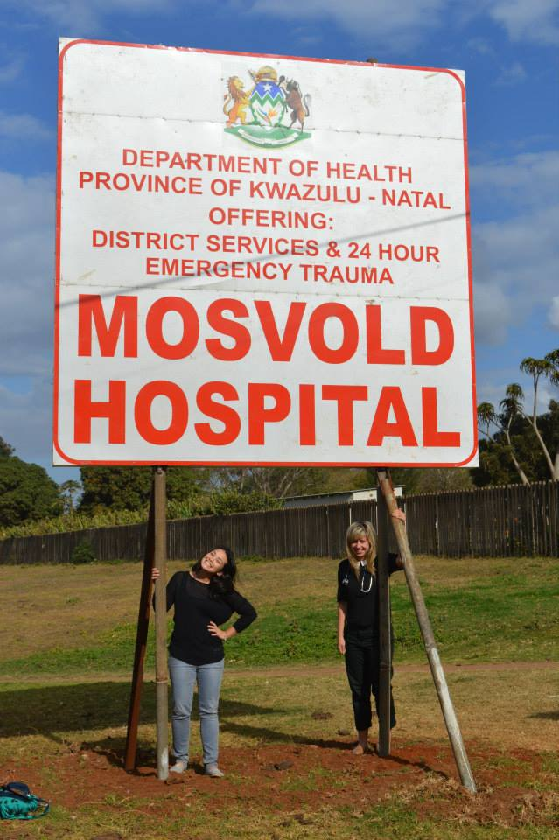

Dates of OOP – August 2014-August 2015
Mosvold Hospital, Ingwavuma, South Africa
http://www.kznhealth.gov.za/mosvoldhospital.htm
http://www.ahp.org.za/

Clinical setting
Rural hospital setting, 246 bed hospital serving a population of 110000.
Clinical resources available
6 wards – Male, Female, Paediatrics, Maternity, TB, Isolation
Radiography – Xray, USS
2 Theatres – Mainly used for C-sections, I+Ds, Cataract surgery
Pathology lab – runs most routine blood tests and sends away to main lab

Main responsibilities of job
Running a ward
Outpatient clinics – seeing patients who present on the day with a range of presentations from routine chronic disease management to trauma and surgical emergencies
Satellite clinics – supporting the nursing staff who run the clinics with reviewing patients and education
On call – covering the hospital, maternity cases, emergencies

Organisational issues:
Small team so you get to know the people you work with very quickly and very closely. 3 excellent senior medical officers who are very experienced and are happy to help and support when asked. Relaxed working environment. Daily ‘tea break’ at 1000 for whole medical team with time to ask questions medical or otherwise.
Salary /annual Leave
Approx R45000 a month after deductions – can give more detail if needed
25 days annual leave + public holidays worked. Expected to work public holidays and then claim the day back in lieu.
Accommodation
Varied accommodation but mostly good – all within hospital grounds. Some houses and some parkhomes.
Communication - internet/phones, privacy.
Good 3G access apart from occasional thunderstorms. Data packages very cheaply affordable.

Description of local community:
Small village – one supermarket within 5 minutes walking distance of the hospital, and a few small local run shops. No banking facilities in the village although there are cash machines. One cafe/art & craft/community centre combined which is run by the wife of one of the senior doctors.
Would recommend having own transport – buy/rent a car, although depending on the other doctors working there at the time there may be someone to buy into a car with or share a car with.
Nearest bigger town is 1h drive away – Jozini.
Public transport is not reliable.
Never felt unsafe in the surrounding community. Very welcoming and appreciative.

Learning opportunities
Huge range of diseases that you’d never have exposure to in the UK.
Growing burden of chronic disease that are bread and butter in the UK so a lot of opportunities to affect care there and share knowledge.
Development of clinical skills.
Learning to work with limited resources.
Learning about yourself and how you work as a doctor in a less structured and streamlined environment.
Outside activities eg.social life / day trips
So many beautiful places to visit on the weekends and during holidays. Day-to-day there was a great community of overseas and community service doctors living within the hospital to socialise with. Usually this was over dinner/braais (bbq’s)/sundowners. Also a network of similar hospitals within the district where there were other UK/European/South African doctors who were always eager meet up and travel.

Lowlights - what did u forget to pack
Bedding – while you can get decent stuff in the big cities, the shops in Ingwavuma are very limited and polyester is not comfortable mid-summer!
Highlights
Every weekend.
What to think about when considering OOP
Be ready to learn a lot and feel out of your depth but if you welcome every opportunity it will all be fine!
It’s a long way from home – get some family/friends scheduled in to visit as soon as possible!

Looking back what was overall benefit of OOP to you
Countless learning experiences
Developing in confidence and as a person
Showing a different side to healthcare
Opening my eyes to future possibilities

Dr Hannah Fox
Kolkata, India
Saroj Gupta Cancer Centre and Research Institute
http://www.cancercentrecalcutta.org/

hannahkilner@gmail.com

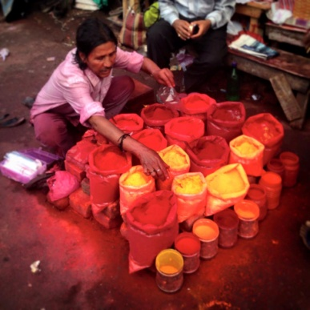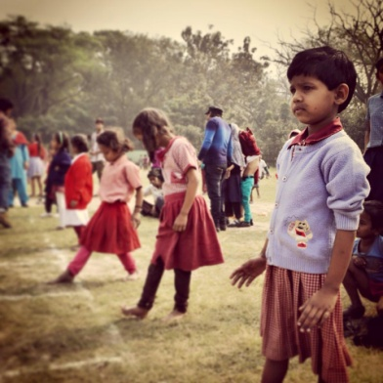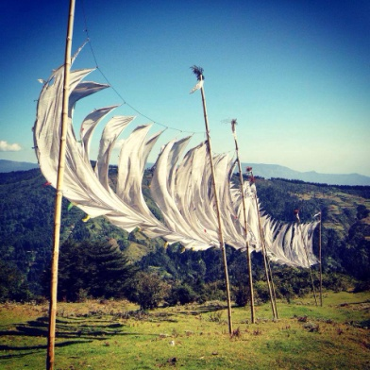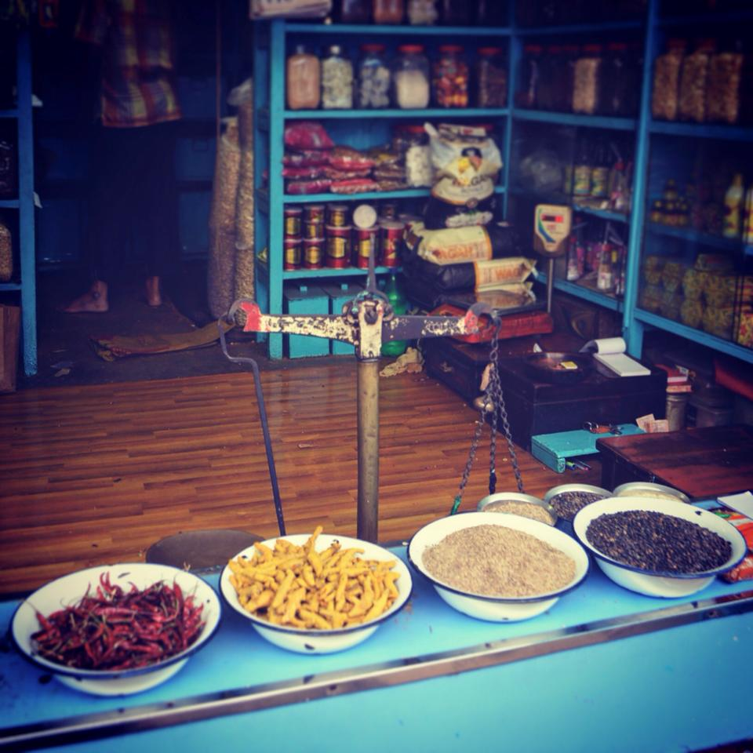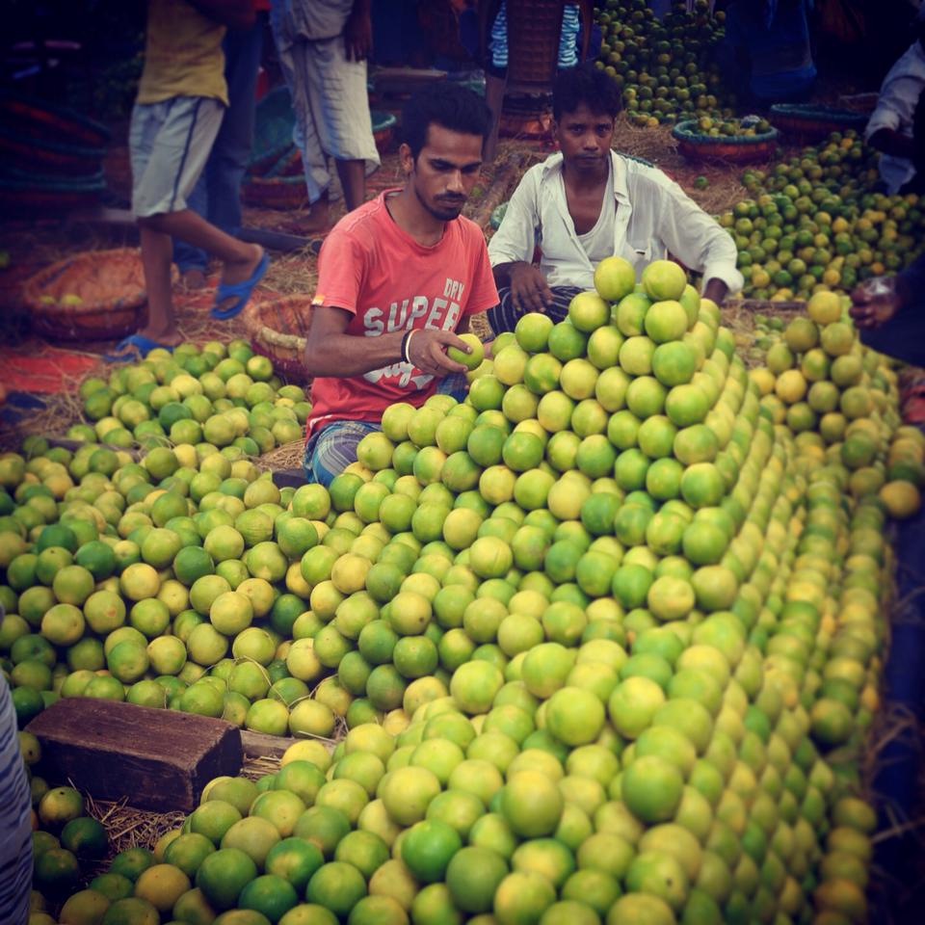

Dates of OOP – August 2014-July 2015
One clinic a week with an NGO ‘Eastern India Palliative Care’ (EIPC)
http://www.eipc.org.uk/
- Clinical setting
- Not-for-profit private tertiary cancer centre set in the outskirts of Kolkata
- Philanthropic ethos - 20% of adult beds, 70% paeds beds and 80% palliative care beds are free for poor patients
- Well resourced with pathological, radiological and endoscopic diagnostic facilities available on site
- Surgical and medical oncology departments, haem onc as well as pediatrics and intensive care
- The Palliative Care Department opened in 2012 and should provide a service to patients across all wards as well an Out-patient service and home care service. The team consists of a consultant, 3 staff grade doctors, a patient co-ordinator and a psychologist.
- At any one time the team would have between 8-20 inpatients to look after
Main responsibilities of job
- Ward rounds in the morning of all the inpatients
- Sitting in Outpatient department in the afternoon/ research work
- Occasional homecare visits
- On Fridays I ran my own outpatient clinic with EIPC and Calcutta Resce (two NGO’s) at a separate site. This was a very basic service, with no access to diagnostics and only limited medications available.
- Teaching – I was involved in 3 separate palliative care courses teaching doctors, nurses and volunteers.
- Presentations at Thurs afternoon doctors meetings (all doctors attend approx 50 or so)
- I ran a Wednesday afternoon ‘psychosocial’ clinic, predominantly to talk to families and often, unfortunately, to break bad news
Organisational issues:
Being the first British doctor to work in this hospital, there was initial confusion about my role within the team. As the year progressed my role became clearer and I felt able to contribute to the palliative care service, particularly through focusing on audits and presenting to the doctors on Thursdays.
The hospital were excellent at assisting with paperwork requirements (registration with Indian medical council, bank account etc)
I had difficulties with my visa, but future applicants will apply for a different type of visa because of my experience.
Salary /annual Leave
Approx Rs 25000-30,000 a month
Annual leave flexible, although not paid for leave days.
Accommodation
Arranged privately – I would advise finding a flat in the city centre and travelling out to the hospital (my commute was approx 30mins)
Communication - internet/phones, privacy.
Good 3G access and cheap wifi can be set up at home
Description of local community:
Kolkata is a fantastic city to live in, despite its poor international reputation. It is surprisingly green and tropical, with huge banyan trees in the street which often accommodate street food stalls, barbers or homes. The street life is incredible – so much to take in and delicious food (if you are brave enough!). Despite being hugely overpopulated, it is a laid back city with a slow pace and everyone is extremely friendly. Unlike many other Indian cities we experienced very little hassle (only when you go to the one back packer street do you experience beggars and hawkers).
Learning opportunities
There is a huge amount of pathology to see. Conducting ward rounds alone means there is plenty of opportunity for independent practice.
I really enjoyed the opportunity to set up new services (psychosocial clinic and palliative care clinic at Calcutta Rescue)
Excellent opportunity to develop teaching skills
Research skills & writing – I conducted two audits and wrote a number of narrative articles for various publications as well as a blog.
Outside activities eg.social life / day trips
Fantastic holiday opportunities – trekking around Darjeeling and into Nepal, scuba diving in the Andaman islands, historical temples at Hampi, beach holiday Goa and more local weekend visits in West Bengal.
Lots of amazing (and very cheap) restaurants. Lots of concerts to attend
Lowlights
The bureaucracy can be incredibly frustrating, and managing expectations – a year feels like a long time at the start but it goes v quickly and it is difficult to really establish new services/ complete projects
Highlights
Feeling incredibly welcomed, at work and in the city. Have the opportunity to ‘live’ somewhere as different and exciting as Kolkata. Working in an area that is in its infancy – lots of international interest within the palliative care world if you wish to write about your experiences. The fantastic food and amazing holidays!
What to think about when considering OOP
Lots of paperwork and organization but well worth it. There will probably be something you forget to sort out – we didn’t do very well sorting out our bank accounts so ended up spending a lot of money on commission.
Go with a partner if you can – great support when things are difficult
We gained so much more from this OOPE than we’d even anticipated – not only brilliant for clinical experience, confidence and new professional opportunities but a wonderful year off to, with so many memorable moments crammed into one year!
Looking back what was overall benefit of OOP to you
This OOPE provides an excellent mix of clinical experience, teaching and research opportunities as well as the chance to develop services and collaborate with local charities. Kolkata is a vibrant, charming and friendly city. And India offers a huge number of beautiful places to travel to throughout the year, including tropical beaches and islands (Goa, Andaman islands), Himalayas for trekking and the ancient temples at Hampi.

For more information please read my blog www.palliativecareindia.wordpress.com or contact me at

hannahkilner@gmail.com

Emma King
E mail emma.lou.king@gmail.com
Out of Programme Experience
August 2014- July 2015
East African Diploma in Tropical Medicine
6 weeks in Moshi, Tanzania
6 weeks in Kampala, Uganda
http://www.lshtm.ac.uk/study/cpd/eadtmh.html

Bwindi Community Hospital
A rural hospital in South West Uganda
http://www.bwindihospital.com/

Clinical setting
A rural hospital in South West Uganda run by an NGO mostly funded by large donor organisations and individuals.

Main job responsibilities
Clinical work in Adult Inpatients, Paediatric Inpatients and Outpatients.
Quality Improvement and Service Development work in Sexual and Reproductive Health.
Country Clinical Lead of USHAPE (Uganda Sexual Health and Pastoral Education) which is a partnership between the hospital and the RCGP funded by THET.

Organisational issues:

It is a relatively small team which allows for good opportunity to really get to know local staff and work closely together.

Salary /annual Leave
Housing is provided and you are given lunch and dinner Monday-Saturday at the Hospital Guest House. A small stipend is provided by the hospital which covers local expenses and is equivalent to about £100 per month.

Mentorship and clinical support
The volunteer doctors work alongside Ugandan trained doctors, clinical officers and nurses. Usually 2 UK trained GPs or GP trainees are recruited on an annual basis so usually a UK colleague is present. Sometimes other volunteer doctors come (usually from the US or UK) on a shorter term basis.

Accommodation
Accomodation is provided by the hospital in “staff quarters” which is a set of cottages for staff and volunteers. The housing is quite basic but there is running water (albeit not heated).

Communication - internet/phones, privacy.
The hospital has wifi as do nearby tourist lodges. You can also buy a dongle but I did not.

Description of local community:
Personal safety is excellent and much better than expected for this part of the world. The hospital is on the border with the DRC but there have been no recent issues with this.

Educational opportunities

As a volunteer doctor I was able to work range of departments and gained a lot of experience. The hospital management are quite flexible and willing to adapt the role depending on interests and competencies of the volunteer doctor.

There are excellent opportunities for developing non-clinical skills, particularly leadership and quality improvement.

Outside activities

There are lovely luxury tourist lodges nearby who make a special effort to welcome volunteers from the hospital.
The local area is stunningly beautiful being right on the doorstep of Bwindi Impenetrable Forest.

Lowlights
It would have been good to bring more relevant equipment for the hospital. It is best to be in contact with volunteer doctors and the hospital before flying out to find out what is needed.

Highlights
The friendships made with local people, staff and fellow volunteers. Being able to make things happen and take the lead on projects.

What to think about when considering OOP .

Having a background in training or medical education would be a huge benefit.

Looking back what was overall benefit of OOP to you
It gave me the chance to pursue and develop my interests. I was given a mandate to do quality improvement work and work on projects that interested me.
Dr Jienchi Dorward
E mail: jienchino@gmail.com

August 2012 to July 2014
Bethesda Hospital, South Africa
Website/ information available: With AHP
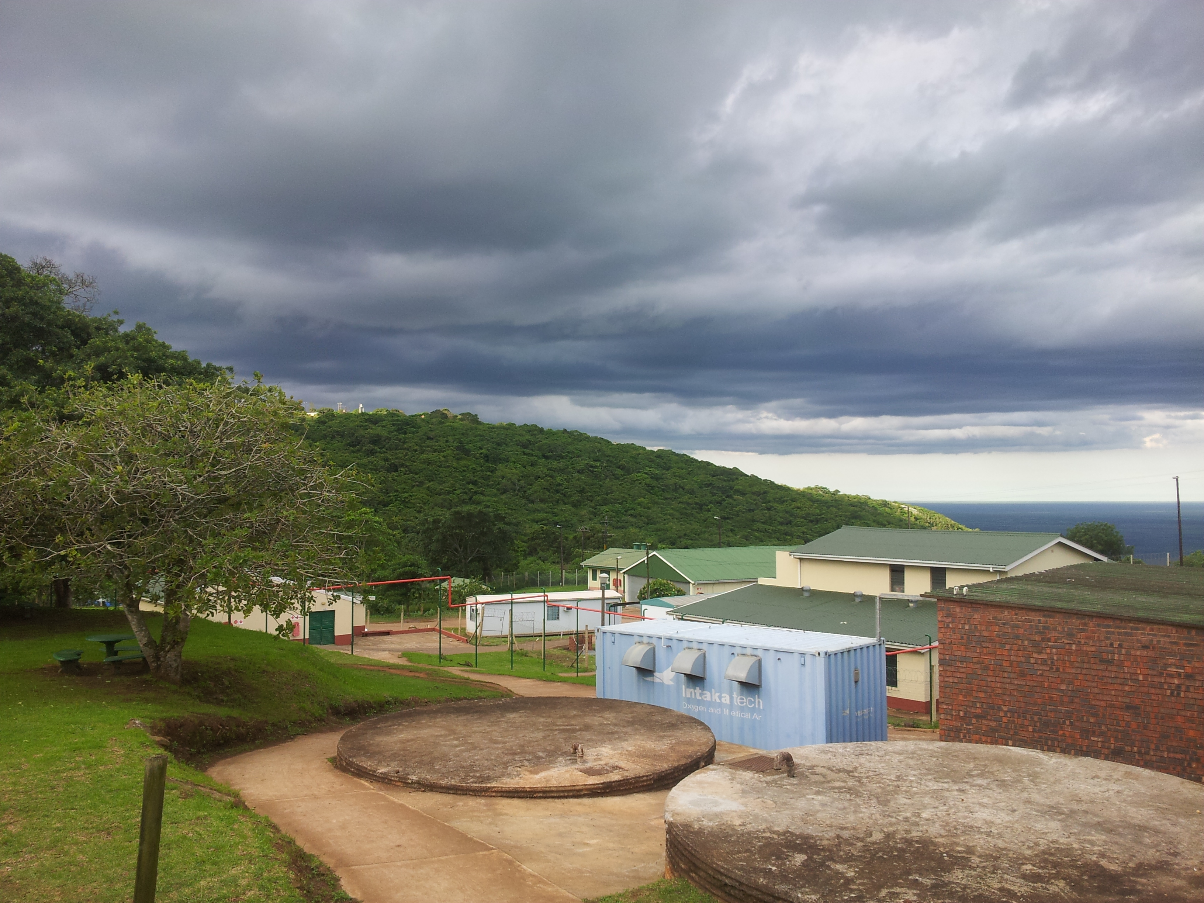

Clinical setting:
Bethesda Hospital is a 222 bed hospital (with 7 primary health care satellite clinics) situated in a deeply rural part of South Africa in the 2nd poorest district of the country. There are very high rates unemployment, severe lack of basic services and very high disease burdens (TB, HIV, childhood malnutrition, diabetes). Patients experience many other problems linked to poverty such as domestic violence, child abuse, substance abuse and crime.
Clinical resources available: Reasonable supply of drugs and equipment. X-ray and USS on site. Functioning operating theatre for caesarean sections and minor procedures. New paediatric and maternity wards completed in 2014. Seven satellite primary care clinics visited by a doctor on a weekly basis.

Main job responsibilities :
Over 2 years I rotated through several services – obstetric ward (with senior supervision where I learnt to do caesarean sections), paediatric ward, adult medicine wards including HIV/TB and then hospital outpatients (which is like a mix of GP and A+E) and satellite clinic work. On call we covered all the hospital services with senior support on site. Work was hard but manageable, how hard varied on how many doctors available.
Service development: I was the medical lead for the outpatient HIV program (7000 patients on ARVs), and as well as clinical work I lead the development of a multidisciplinary program of adherence support for the 10% patients with virological failure.
Organisational issues:
Work colleagues/team dynamics: The medical team was great and supported each other well, with a good mix of overseas and South African doctors from a variety of ethic groups and backgrounds.
Salary /annual Leave: From memory it was 25 days annual leave, the salary was approximately R450,000 per annum, with free hospital accommodation on top.
Mentorship and clinical support: The senior team at the hospital included some of the best bosses I have ever worked for, with excellent leadership and team building, as well as clinical, skills. I felt like I could learn a lot from them, they invested in teaching me and allowing me to attend educational activities e.g. conferences. I also felt like my contributions towards the team were valued too.
Accommodation: I lived in a very nice shared house with other doctors on site within the hospital.
Communication - internet/phones. In the hospital we had to use a 'dongle' for internet, there was no broadband connection. For a faster connection one had to drive 20 minutes to the nearest town.

Local community:
Rural areas in South Africa are much safer than urban areas. I never had any problems regarding personal safety or crime. Ladies would jog on their own in evenings outside the hospital site.

Learning opportunities: The most important thing I learnt was how to make decisions, and think laterally in challenging situations

Outside activities: The hospital is in a beautiful location with lots of surrounding beaches and game reserves which hospital staff regularly visited at weekends.

Lowlights - what did you forget to pack. You can buy everything you need in South Africa, except for a 4 way UK extension lead for all your electrical items.

Highlights: These were the best 2 years of my medical career so far. I would recommend doing 2 years as you get more out of your second year once you are settled in.

What to think about when considering OOP: I and some friends took Zulu lessons before going out there, and then continued these when in South Africa, this helped a lot and I strongly recommend it. Necessary procedures were all well taught in the hospital. Friends who went to other small rural hospitals sometimes did a placement in an Obstetrics Department somewhere larger first to learn how to do caesarean sections.

Overall benefit of OOP: I developed hugely as a doctor and a person. I learnt to deal with unfamiliar situations in a systematic way, to make decisions better and to take responsibility for those decisions.

Zara Usmani
E mail: Zara.Usmani@glasgow.ac.uk
Academic Fellowship

Aug 2013- July 2014
University of Glasgow and Harvard University
Website/ information available
http://www.gla.ac.uk/researchinstitutes/healthwellbeing/staff/?action=person&id=4eddebe18093

Main responsibilities of job:
Working as a research fellow in an academic primary health care unit gave me the opportunity to work along side academic GPs and understand better the role of an academic GP. I took a course in research methodologies with masters in primary health care students and supervised a BSc student through her research project. I also led research into a study looking at elderly populations aged 85+ which is currently being written up for publication. I was a visiting academic at the Harvard School of Public Health for 4 months where I took classes related to global and population health. This included classes looking at universal health coverage which I am particularly interested in.
Educational opportunities:
The OOPR has given me the opportunity to broaden my horizons within general practice. The skills I have aquired will be used to bolster my work as a GP trainee and GP in the future. I also felt very well supported by Dr Kiernan at the RCGP who supported me in developing my eportfolio.

Outside activities:
The academic institution was very friendly in Glasgow and there were many social activities outwith work. Similarly at Harvard there were lots of social activities for students and I made long lasting friendships with academics and professionals from many fields.
Highlights:
Learning from academics renowned in their field. Sailing on the Charles River
What to think about when considering OOP:
Financial implications of a year out: can be expensive but I feel worth it.

Looking back what was overall benefit of OOP to you
Helping me to pursue my interest in global primary health care.

Mount Abu Rajasthan India
Dr Camille Gajrhia
OOPE Aug 2011- July 2012
camilles@doctors.org.uk
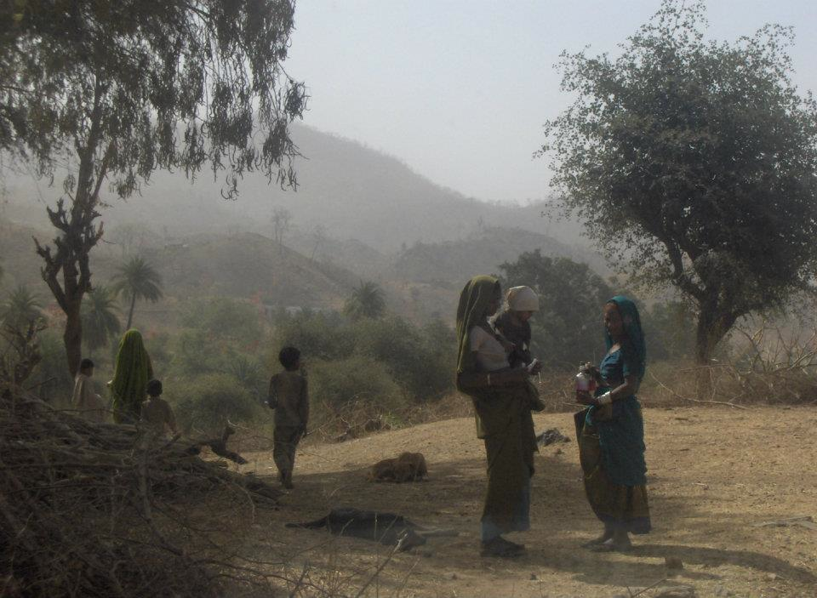
I took a Deanery Out of Programme Experience in rural India in 2011. I aimed to gain hands-on experience in specialities not covered by my training and broaden my perspective.
The Indian government provide free healthcare, but resources are limited and many private and charitable organisations fill the gap. I was based in a hospital that was run by and primarily catered for devotees of a large new-age sect who visited from all over the world but was open to all. The hospital was thus well resourced with trained staff and facilities such as an intensive care unit, dialysis machines and a wide range of medication although contraceptives were not offered. Despite the funding, an organisational structure and an aim to have good standards, there were major gaps in community care, access and in some cases accountability. This made work ethically taxing, something I was expecting from an OOPE but not in this way. In a culture of hierarchy and resistance to change, challenging practice was complex but also therefore satisfying. I had some opportunity to do outreach work and tried to develop this further by collecting and presenting evidence of need to cater more for the local community and tribal population. I also contributed towards curriculum development and regular teaching for nursing students.
Taking part in healthcare provision in a different culture offered a unique perspective. Nationwide, primary care was underdeveloped. Indian doctors train either in allopathy or traditional medicine, although the curriculums overlap and cross over in the settings they work in. However there is not much integration between the approaches and some patients consult both services simultaneously or in tandem. Junior doctors routinely intubated patients but were not confident with basic prescribing. Standards and expectations were different; I learned to find my own mentors and felt supported while having the independence to create my own learning experience.
A six to seven day week with six to twelve hour shifts was normal. I experienced clinical situations and patients with histories and signs that I would not have seen in the UK. The workload was varied but was usually much quieter than UK clinical settings, allowing me space to think broadly and develop services. Living on-site meant electricity and internet access was usually available and I was much more involved in the team than otherwise may have been possible, both in terms of work and socially. I was able to go back to review a patient, assess ill staff in their rooms, or join a colleague for midnight bhel puri and icecream on ITU.
Learning some Hindi or the official language of the state you wish to work in would be useful before starting out in a rural setting, though most medical staff speak English to varying extents; local languages vary greatly. The people were welcoming, colourful, hard-working and resilient. Travelling to a rural area was full of uncertainty but I always felt safe. Fellow passengers became friends on long journeys, sharing snacks and stories.
As I was working for a charity, the remuneration barely covered costs. Annual leave was unpaid and a little difficult to obtain possibly as my hosts had no previous experience of employing foreigners (who would want to travel), but this got better perhaps as they got used to the idea. I was based in a scenic hilly location with a tolerable climate and often trekked before or after work. There were opportunities to use local hotel facilities such as tennis courts and swimming pools. Community festivals were a fantastic riot of music and colour.
The benefits to me unfold as time goes on- my overarching initial reaction was an increased appreciation of the NHS and our training, despite its deficiencies. I gained leadership skills that I would not have had the opportunity to practice at this stage of my career in the UK. I enjoyed discovering new experiences with like-minded people from all over the world. I would strongly encourage anyone interested in an OOPE to get in touch and enjoy the adventure!
Camille
camilles@doctors.org.uk

Dr.Katie Cocker
Clinical OOPE
August to February 2013 Auckland, New Zealand
February to June 2013 Santiago Atitlan, Guatemala
http://www.whitecross.co.nz/jobs.html http://www.hospitalitoatitlan.org/
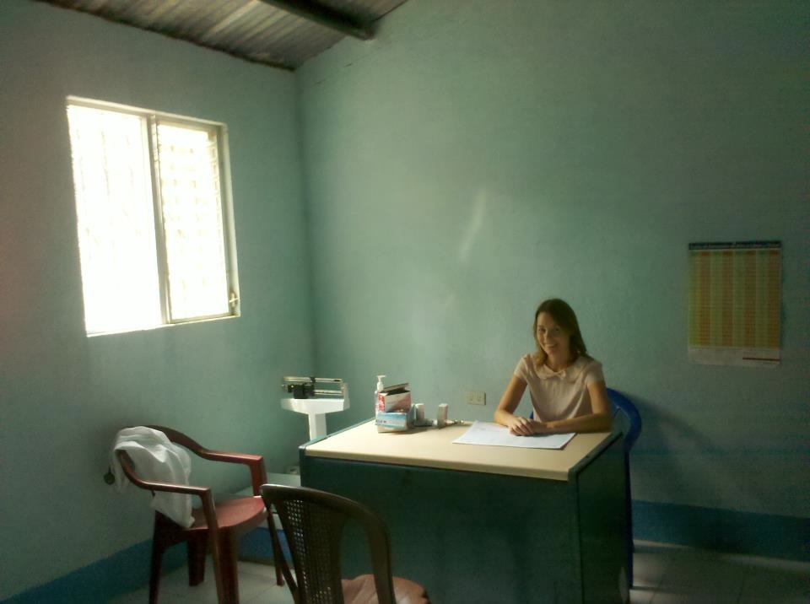

Wanting to utilise and improve my Spanish , I spent four and half months as a volunteer doctor at Hospitalito Atitlan which serves a predominantly Mayan population in a deprived, rural area of Guatemala. The hospital offers maternity care, elective and obstetric surgery, and emergency department, small inpatient ward, and general medical outpatient clinics. It is staffed by foreign volunteer healthcare professionals and local doctors and nurses. In order to fund this, I also organised 6 months working shifts in different accident and medical clinics in Auckland New Zealand.
My OOPE showed me two extremes of healthcare systems. In Auckland I was assessing and treating walk in patients in a private urgent care setting. People with medical problems paid a fee to see the doctor; accidents were covered by a goverment insurance scheme. If anyone had a serious condition they were referred to the nearby hospital. We sutured minor wounds and casted minor fractures but the acutely unwell were transferred.
In Guatemala rugby injuries made way for machete wounds but, for many patients, my colleages and I were the end of the line. I worked mainly in the general medical outpatient department but when patients got complicated I couldn't usually refer them to a cardiologist or a nephrologist. You have to up your game and mug up on specialist care because patients don't have the resources for a second opinion. Your capacity for tolerating uncertainty undoubtedly increases as you do not have the luxury of experts and investigations.
I also did a number of 24 hour on calls when I was responsible for inpatients and all emergency cases. Patients who were seriously unwell or needed emergency surgery could be sent to the national hospital but, for reasons of finance or fear, many refused.
I became much more aware of resource management during my time away. Hospitalito Atitlan had basic lab tests, xrays and ultrasound but patients had to pay a means tested fee for these and most were very poor. Conversely, in New Zealand, people who had accidents got the best of everything from plaster casts to physio but was it all really necessary?
My OOPE was an opportunity to learn for the love of it again and I was lucky enough, in both locations, to be surrounded by experienced clinicians who were happy to share their wisdom. Freed from the pressures of NHS A and E targets and DOPS forms, In NZ I found myself happy to ask for help to finally get the hang of suturing and xray reading.
In Guatemala the patients' reliance on us had me heading for the text books and increasing my understanding of chronic diseases and a few rarities like typhoid fever and strange worms. The New Zealand clinics were set up around doctors stations where you naturally discussed interesting cases with colleagues. In Guatemala, although you could be working alone, there were always other, often long term, dedicated volunteers who were happy to be called in any time of day or night. Comversely there is an expectation that you will help supervise and teach the medical students of many nationalities who have placements at Hospitalito and also get involved in giving presentations at the daily handover meeting.
What was tough? Very little in New Zealand to be honest! The company I worked for offered excellent working conditions and the job was fun and satisfying. I had the opportunity to be an independent practitioner with plenty of support if I needed it. Urgent care doesn't really exist in this way in the UK but it's basically A and E without the stress or GP without the paperwork!
In Guatemala it was hard to have my eyes opened to the frustrations of development work. Politics finds its way into the most altruistic of projects. Volunteers wonder why patients have to pay when they are working for free; locals argue the whole thing would collapse if they didn't. And why are you sometimes left twiddling your thumbs in an empty clinic when you know there is need all around? There are still many barriers to access that must be overcome.
For me one of the highlights of the work in Guatemala was the weekly visit to community outreach posts where volunteer doctors can work alongside the permanent nursing staff who offer basic primary care. However, this could also be difficult, as patients needing further input would often refuse to seek it and this can be hard to accept.
What was suprising? Perhaps how patients on either side of the world and either side of the poverty gap have some remarkable similarities. Patients can still have psychosomatic symtoms in poverty. They can still be worried well. And they can still be very demanding even when you're giving them your services for free.
In New Zealand I took off nearly every weekend to see a different part of this beautiful country and enjoy the outdoors lifestyle for which it is rightly famed. I rented a tiny flat (albeit with a pool, gym and jacuzzi!) and a tinier car and spent as much time out of both as possible.
In Guatemala safety concerns do limit your physical freedom but the social network I built up with other volunteer doctors and students from the UK, the US and Europe was one of the highlights of the trip and slowly you build up your confidence to venture further afield. Flexible leave meant that I also had the opportunity to travel to Belize and to other parts of Guatemala during my stay. I lived in what was essentially a shed in a garden but what a garden it was! Tropical birds and plants and a view of a volcano! We had a priviliged water and electricty supply but even we were not immune to the frequent tropical storms and subsequent power loss.
For me the combination of clinical work in a developed and a developing country made for a unique, enriching and unforgettable OOPE. The highlights, both professional and personal, are too many to mention. The time and effort that it requires to orchestrate, however, should not be underestimated!
Katie Cocker

Dr Caroline Scott

E mail carolinemscott@btinternet.com
August 2009 -July 2010
Mosvold Hospital, KwazuluNatal, South Africa

Website/ information available;
http://www.kznhealth.gov.za/mosvoldhospital.htm
also check out this youtube video tour http://www.youtube.com/watch?v=WAJG3BgTJiQ
or my own blog http://carolinegoesrural.blogspot.co.uk/2009/08/penultimate-day.html
Clinical resources available
Hospital. Had x-ray and basic pathology (water-dependent). Operating theatre on site. 3 hours to nearest tertiary referral hospital.
Also covered 10 outlying clinics in local area.
Main responsibilities of job :
Work itself is interesting and varied-ish; lots of HIV, TB and the things that go along with those. Also basic medical conditions like BP and diabetes. But lots of managing them with limited specialist input and at times, medications. Also snake bites and general trauma. On call you are also responsible for maternity (and c-sections).
Visiting outlying clinics.

Organisational issues:
Work hours-wise, you work hard. You're part of an 8-10 doctor team staffing the hospital 24 hours a day, 7 days a week. So you normally work Monday to Friday 7.30am-4.30pm, you do about one 'on call' every other week (an on call involves working during the day, carrying a mobile phone overnight for 'emergencies' (and there were normally one or two calls per night, a bad night involved no sleep) and then working until lunch the next day. Weekends wise there are two doctors (taking it in turns to be first and second on from Friday morning to Monday lunch) so, you do about one a month.

Accommodation is basic but luxurious compared to the locals; brick houses with running water and electricity most of the time. Internet was mainly through dongles but wasn't bad at all. As long as you don't want to upload photos or download movies.

Description of local community:
The environment is isolated; you're 4 hours drive from Durban (the nearest city), an hour from the nearest 'town' (ie. place with a restaurant). But there are a few shops near the hospital where you can buy food. And the upside of the isolation is the community spirit it produces amongst hospital staff and other people around; you were never lonely. Things to do in the village were quite different to how you probably socialise now; more football and rounders, board games and video nights. But very fun.

Safety not a problem; you lived inside the gated hospital complex. Didn’t try to go to the local shebeen (bar) though.
Educational opportunities : Huge amount of learning about managing limited resources, team work and working within varied cultural values.
Outside activities:
Spare time was always used to the max, and there is so much to see and do in KZN; diving, safari parks, trips to Swaziland, trips to Mozambique, white water rafting, let alone the rest of SA which you can access in your 20 days annual leave.
Lowlights
Isolation from your family and friends; don’t forget to pack your laptop and phone.
Highlights:
The privilege of being allowed in to people’s lives
What to think about when considering OOP:
Well worth learning a little Zulu prior to arrival; will earn you enormous respect. Also, if the opportunity presents (ie. in an O&G job), get as hands on as possible. The experience will be well worth it when you’re going it alone.
Looking back what was overall benefit of OOP to you:
Incredible life-changing experiences. Both good and bad.

