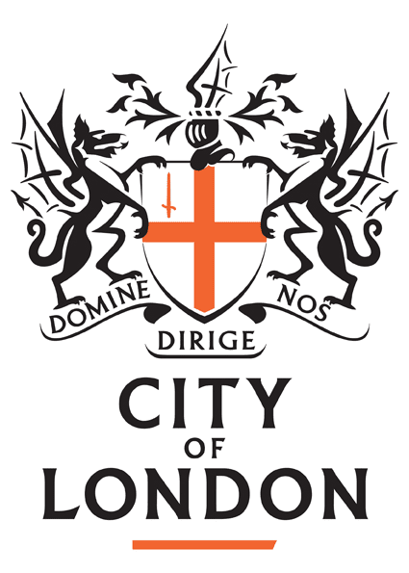 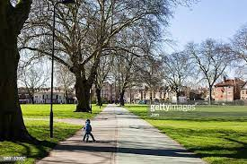 

Hackney and City Public Health team welcomes new public health trainees and is a vibrant and dedicated team, serving the populations of both Hackney and the City of London and known for being innovative and passionate about improving the health of our local populations. Our trainees are important to us and we make sure that they have an interesting and productive experience. Having recently been restructured, the team is on a journey to transform the authorities, to take a ‘Health in All Policies’ approach.

Hackney is one of the UK’s highest performing local authorities, serving one of London’s best places to live and work.  We have achieved a huge amount: our services, our schools, our public spaces are all amongst the very best.  We have changed the reputation, not just of the Council, but of Hackney itself. Bringing jobs and investment into the borough, securing the legacy from the 2012 Games, and making this a place of which we can all be proud. The City Corporation is the governing body of the Square Mile, dedicated to a vibrant and thriving City, supporting a diverse and sustainable London within a globally-successful UK, aiming to contribute to a flourishing society, shape outstanding environments and support a thriving economy.

We have a range of exciting opportunities for trainees, the following are just a few examples.:-

* City & Hackney's Health Inequalities steering group have developed a suite of resources to embed health equity in local decision-making. There are opportunities to support Hackney Council priority of improving the lives of Young Black men as well as working with Turkish, Vietnamese and Charedi orthodox jewish populations
* The City & Hackney Population Health Hub (formed during 2021) aims to provide timely and actionable intelligence, develop practical tools and lead specific projects to influence and support system partners to improve population health and reduce health inequalities.. The Hub's work plan is in development, but includes a number of projects covering six broad functions: data and analysis; evidence and guidance; research and evaluation; community insight; service improvement; embedding prevention and health equity in service planning and delivery.

Hackney Council is based in Hackney Central overground, while the City of London offices are in the Guildhall, near St Pauls, Liverpool Street and Moorgate. We are spoiled for choice for delicious food options! While currently predominantly home based, the team is planning to move back into the office for two to three days a week, though the trainee is welcome to work full time in the office if they prefer. We currently have a first year Public Health trainee and a GP trainee and sometimes have more senior trainees returning to complete projects/competencies.

The Educational Supervisor responsible for the role is Dr Nicole Klynman ([Nicole.Klynman@hackney.gov.uk](mailto:Nicole.Klynman@hackney.gov.uk)). Please contact her if you require any further information.

The Director of Public Health is Dr Sandra Husbands.