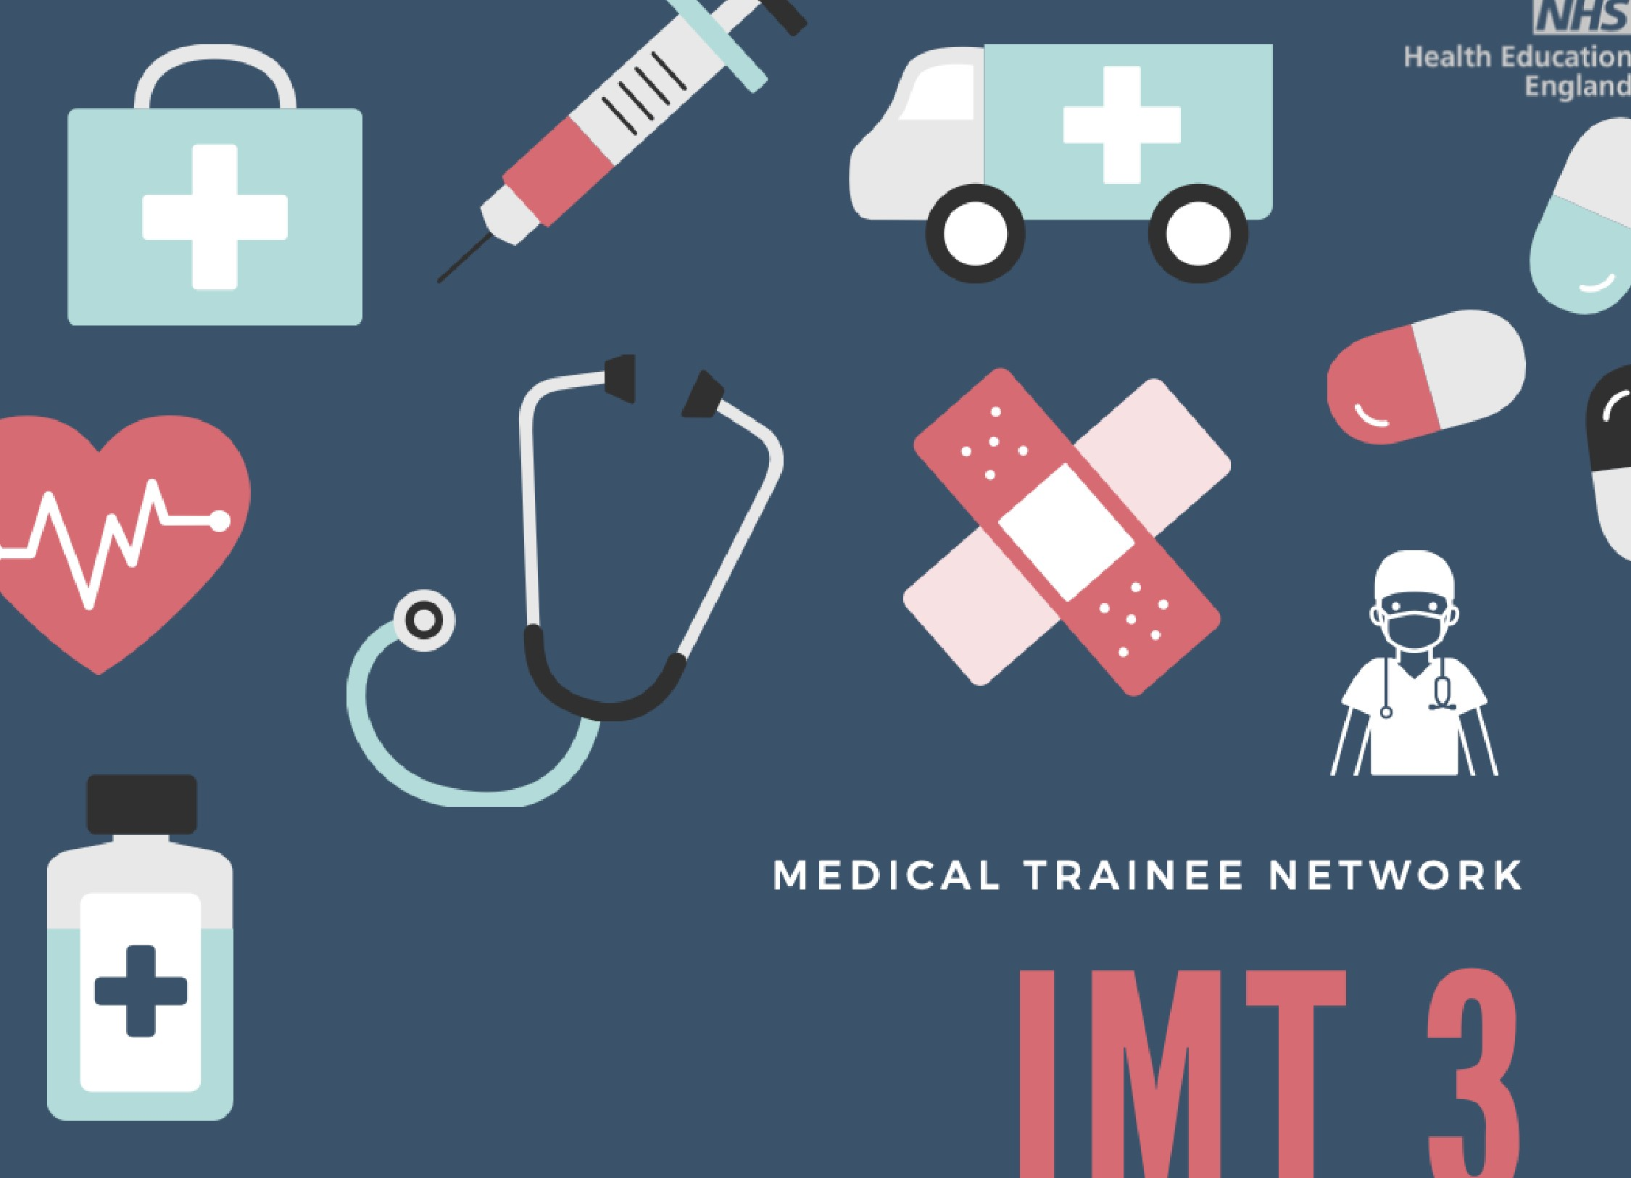

29

th

January: PALLIATIVE CARE

Click to Registe

[r](https://us02web.zoom.us/webinar/register/WN_HvFfjUx7SGeQFWU34Siirw)



29

th

February: ACUTE MEDICINE

Click to Registe

[r](https://us02web.zoom.us/webinar/register/WN_WfAa2W0DTZerTrihzVwCzA)

12

th

March: SURGICAL LIAISON

Click to Register

27

th

March : MATERNAL MEDICINE

Click to Registe

[r](https://us02web.zoom.us/webinar/register/WN_ie7bbnegQPeAi5R4BhhmuQ)



Course organisers: Arun

Sivananthan

, Chris Harlow, Sam Seitler