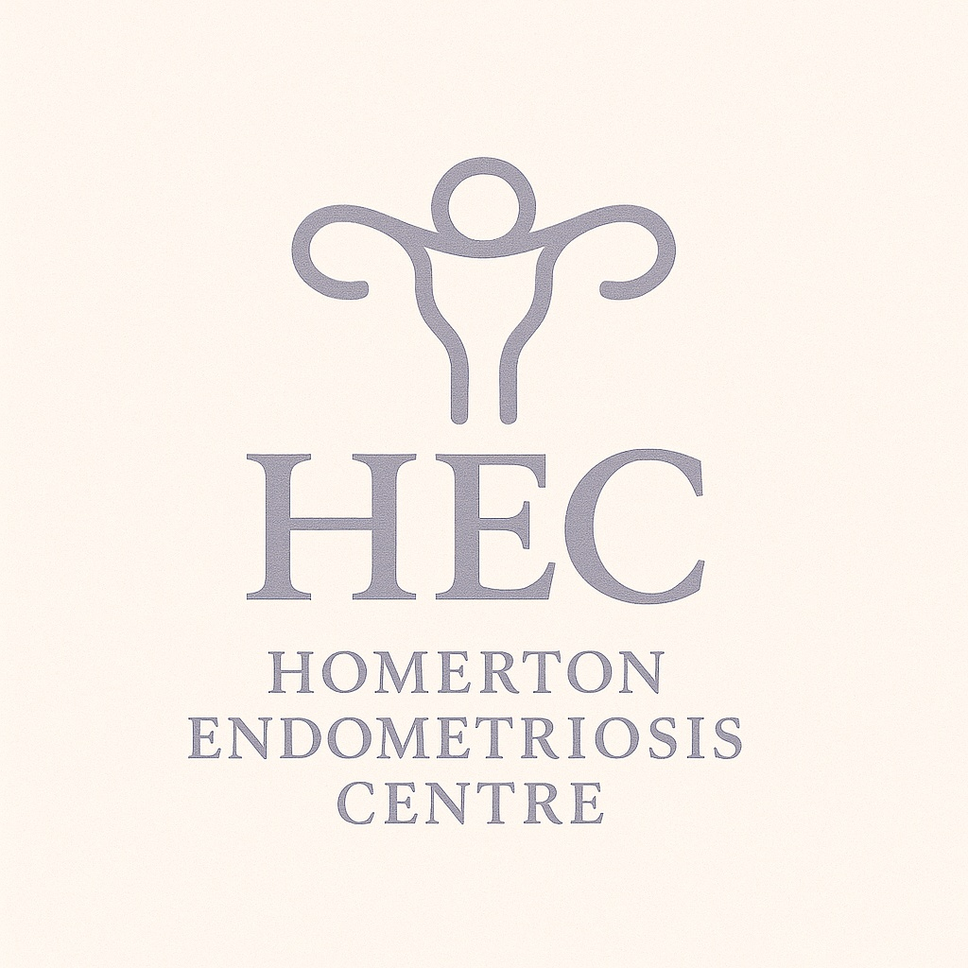



**Homerton and North Middlesex University Hospital NHS Trusts**

**Department of Obstetrics and Gynaecology**

**Senior Clinical Fellow in Obstetrics & Gynaecology**

Special Interest in Advanced Minimal Access Surgery / Endometriosis / Management of Complex Non-Malignant Disease (MCND) SITM

This unique two-year Senior Clinical Fellowship offers an exceptional training opportunity across two nationally accredited BSGE Endometriosis Centres—Homerton University Hospital and North Middlesex University Hospital (NMEC). The programme is designed for experienced trainees with a strong interest in advanced laparoscopic surgery and complex benign gynaecological conditions. Fellows will complete their first year at Homerton and their second year at NMEC, benefiting from a wide variety of surgical cases, multidisciplinary input, and academic development.

## Year 1 – Homerton Endometriosis Centre

Homerton University Hospital serves a diverse population in Hackney and The City, offering high-risk obstetrics, general gynaecology, and subspecialty services. The Endometriosis Centre is led by dedicated consultants and supported by a CNS, colorectal and urology surgeons, fertility specialists, and pain management teams.

The fellow will be mentored by three consultants, attend 2–3 theatre sessions and 2–3 clinics weekly, and help coordinate the monthly Endometriosis MDT. There are opportunities for simulation training, audit, teaching, and participation in national research trials such as ESPriT2 and DIAMOND.

## Year 2 – North Middlesex Endometriosis Centre (NMEC)

NMEC is a high-volume surgical centre headed by Mr Parveen Verasingam and supported by a multidisciplinary team including colorectal, urology, and radiology specialists. It is renowned for advanced laparoscopic procedures including day-case myomectomy, transanal disc excision, and ureteric/bladder reconstructions.

Fellows will gain hands-on experience in theatre, participate in research and MDTs, and attend funded national training courses. A Travelling Fellowship to another UK BSGE centre is also included.

## Training Objectives

- Develop surgical proficiency in excising mild to moderate endometriosis

- Gain experience in laparoscopic hysterectomy, fibroid surgery, and adnexal procedures

- Gain experience in the medical and surgical management of deep endometriosis

- Engage in multidisciplinary patient care including colorectal, urology, fertility, and radiology input

- Participate in research, audit, and education

- Complete the MCND SITM module over two years

## Proposed Weekly Timetables

**Year 1: Homerton University Hospital**

|  |  |  |  |  |  |
| --- | --- | --- | --- | --- | --- |
|  | Monday | Tuesday | Wednesday | Thursday | Friday |
| Week 1 | AM - Endometriosis Clinic / PM - Theatre | Cover/SITM | AM – OPH / PM - Acute Gynae Clinic | Theatre (all day) | AM – Cover/SITM / PM – Cover/Admin |
| Week 2 | Endometriosis Clinic (all day) | AM – Cover/SITM / PM – General Gynae Clinic | AM – OPH / PM - Acute Gynae Clinic | Theatre (all day) | AM – Cover/SITM / PM – MDT Admin |
| Week 3 | Endometriosis Clinic (all day) | Endometriosis MDT / Cover/SITM | AM – OPH / PM - Acute Gynae Clinic | Theatre (all day) | AM – Cover/SITM / PM – Cover/Admin |
| Week 4 | Endometriosis Clinic (all day) | Cover/SITM | AM – OPH / PM - Acute Gynae Clinic | Theatre (all day) | AM – General Gynae Clinic / PM - Theatre |

Cover/SITM = On call duties (acute gynaecology/delivery suite/emergency obstetric unit) or SITM activities (e.g., MDTs with Colorectal, Urology, Fertility, or Radiology).

**Year 2: North Middlesex University Hospital**

|  |  |  |
| --- | --- | --- |
| Day | Morning (9:00–13:00) | Afternoon (13:00–17:00) |
| Monday | Theatre | Theatre |
| Tuesday | Endometriosis Clinic | ANC |
| Wednesday | GOPD | GOPD |
| Thursday | Theatre | Endometriosis MDT |
| Friday | Endometriosis Clinic | SPA / Theatre (1:4 rotation) |

## Contact Information

For Homerton Year 1:

Miss Marianne Wild, Endometriosis Centre Lead – Marianne.wild@nhs.net

Mr Vikash Mistry, College Tutor – Vikash.Mistry@nhs.net

For NMEC Year 2:

Mr Parveen Verasingam – [parveen.verasingam2@nhs.net](mailto:parveen.verasingam2@nhs.net)