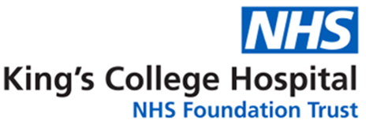Neuro Anaesthesia Regional Training Day  
27th November 2025  
Tina Chan Room, Anaesthetic Department, King’s College Hospital

(Ground floor, Cheyne Wing, main entrance, turn right, turn left at General Ultrasound and the Anaesthetic Dept. is on the left)

08:30 - 09:00 Registration

Neuro Radiology

09:00 - 09:30 Naga Kandasamy Interventional Radiology for Thrombectomy

09:30 - 10:00 Smita Gosavi Anaesthesia for Thrombectomy

Spine

10:00 - 10:30 Gordan Grahovac Surgical Management of Cervical Spine

10:30 - 11:00 Brenda Nyamazi Cervical Spine Trauma and the Airway

11:00 - 11:30 Irene De la Cruz Perioperative Management of Spinal Surgery Patients

11:30 - 12:00 Break

Oncology

12:00 - 12:30 Sian Murace Intraoperative Neuromonitoring

12:30 - 13.00 Holly Jones Anaesthesia for Awake Craniotomies

13:30 - 13.30 Jose Lavrador Neuro-oncology: A patient’s journey

13.30 - 14:30 Lunch (not provided)

pEEG

14:30 - 15.00 Ian Davies TIVA Models/Applications of processed EEG

Paediatric Anaesthesia

15:00 - 15.30 Sarah Nour Fundamentals of Paediatric Neuro Anaesthesia

Neuro Vascular / Critical Care

15:30 - 16:30 Ahilan Kailaya-Vasan Neurovascular Surgery

16:00 - 16:30 Holly Jones Anaesthesia for Neurovascular Surgery

16:30 - 17:00 Carmen Lopez-Soto Intracranial Pressure Monitoring

17:00 Close