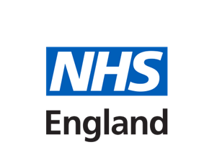
…medical educator with a relevant educator course
Foundation trainees
Medical students
Non-medical learners
GP trainees
…primary care nurse educator with NMC’s SSSA
…primary care nurse educator with SSSA and NHSE Multi-Professional Educator Course
…primary care nurse educator with NHSE Multi-Professional Educator Course
Nurse learners only
Non-medical & nurses learners
Non-medical learners only
What Professional Groups Can I Supervise?
I am an accredited……

…non-medical educator with NHSE Multi-Professional Educator
Course
Other non- medical learners
Pharmacy learners
Physio
learners
Paramedic
learners
Podiatry
learners
First
Contact Practitioner
learners
Physicians Associate
learners
Advanced Clinical Practitioner
learners

